**Custom LangGraph Agent**

**Lab Instructions**

In this lab, you will register an **external agent** in watsonx Orchestrate. The agent is built using LangGraph and deployed on watsonx.ai as an AI Service Endpoint.

The agent, named Traffic Agent, uses a REST API call to retrieve real-time traffic information for a given location. It was created with the watsonx.ai LangGraph template.

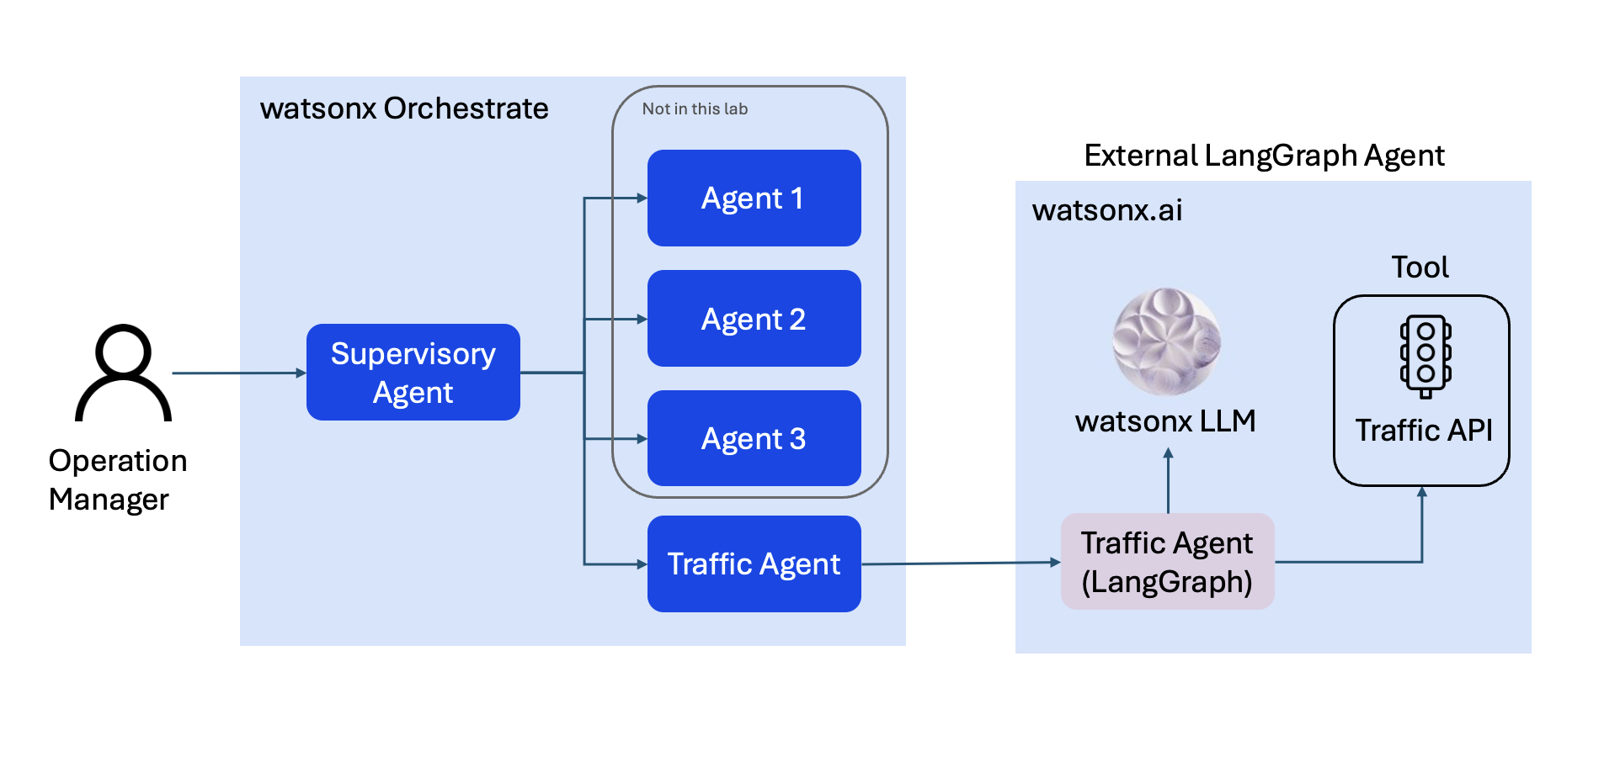

# Part 0: Before You Begin

Before deploying the agent, ensure that you have a User API key in the watsonx.ai Runtime instance where you intend to deploy.

1. Go to your watsonx.ai Runtime instance in IBM Cloud. [IBM Cloud](https://cloud.ibm.com/). Click the hamburger menu (☰) in the top left corner, then select **Resource List**.

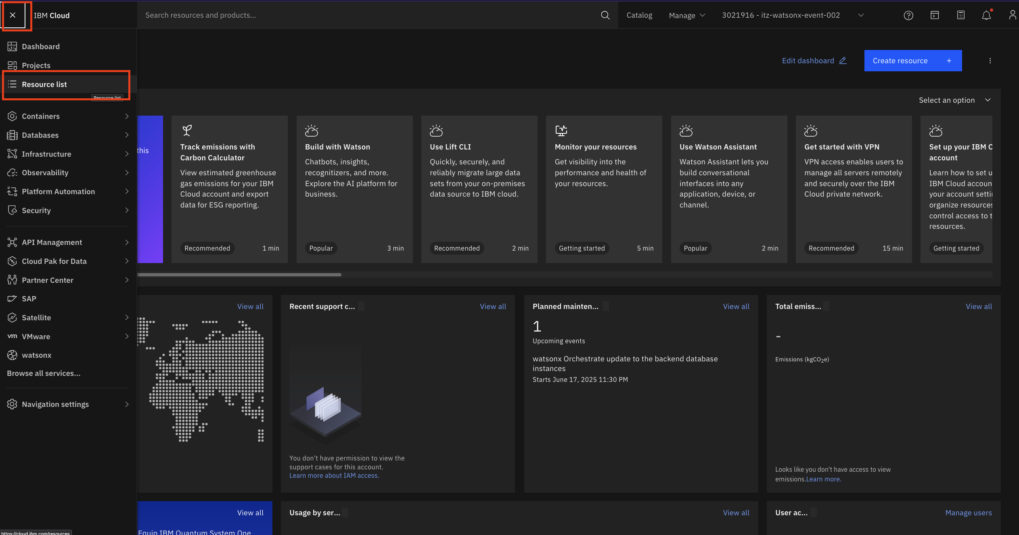

1. Click on the instance name listed under the watsonx.ai Studio product.

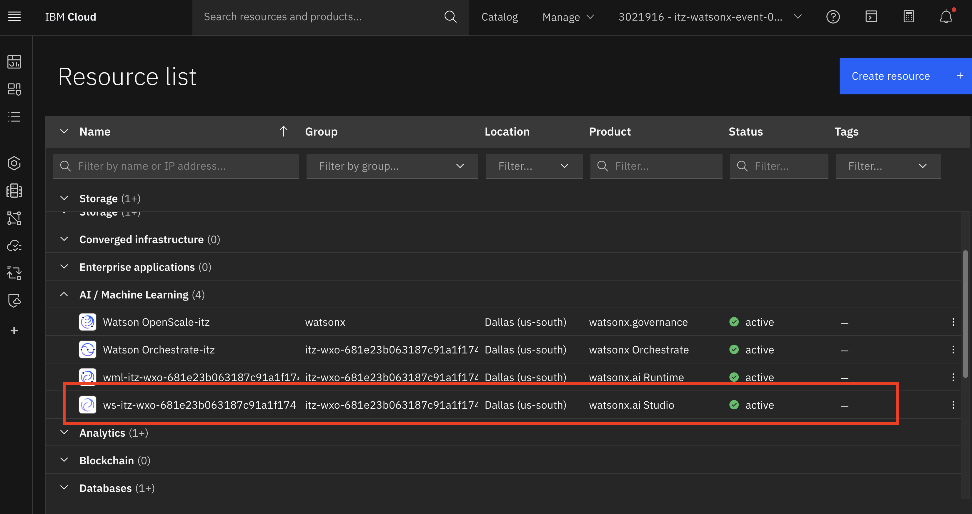

1. Click the arrow next to **Launch in**, then select **IBM watsonx** (you may be prompted to sign in again).

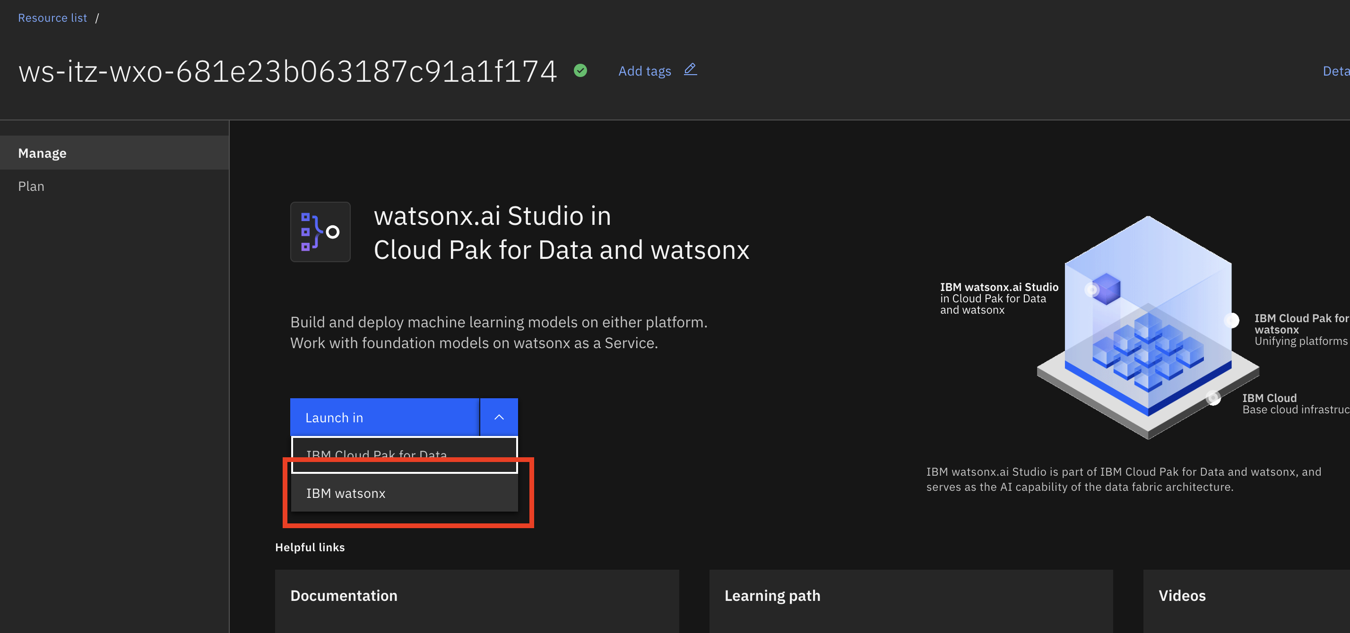

1. Click the user icon in the top right corner and select **Profile and settings**.

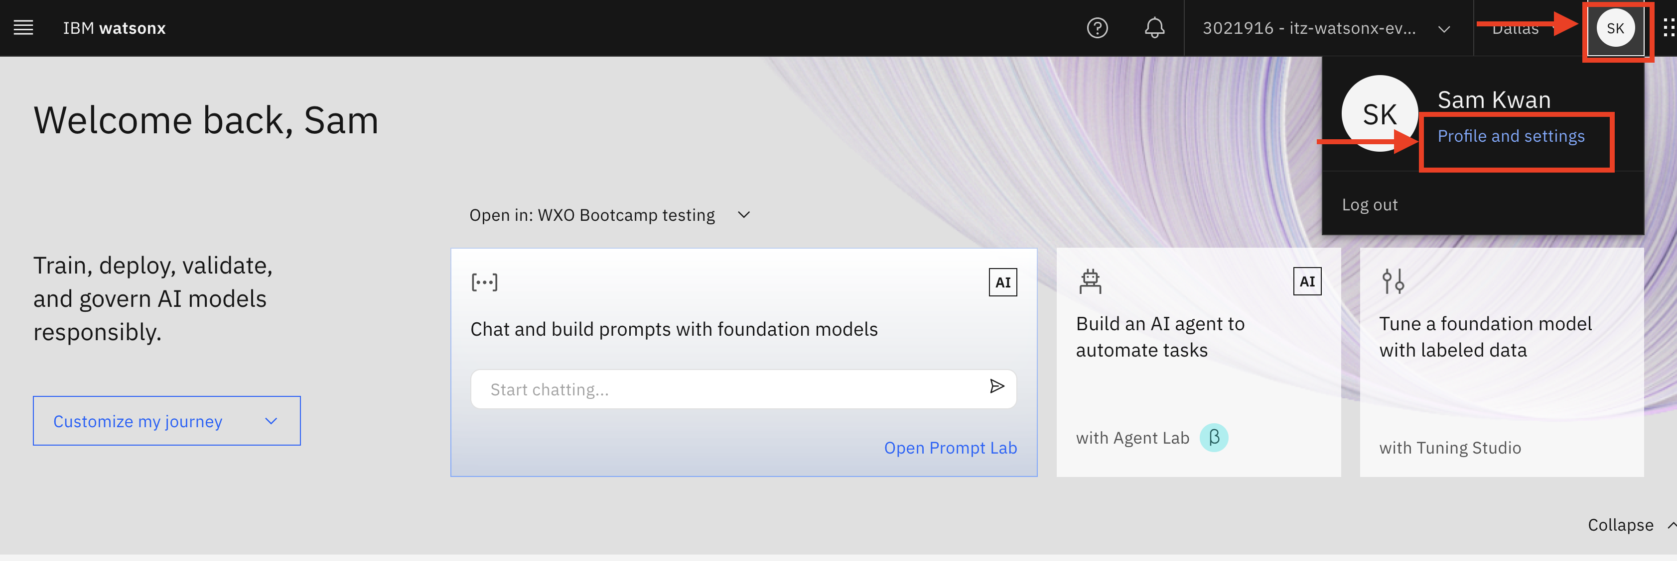

1. Go to the **User API key** tab. If you don’t already have a key, click **Create**.

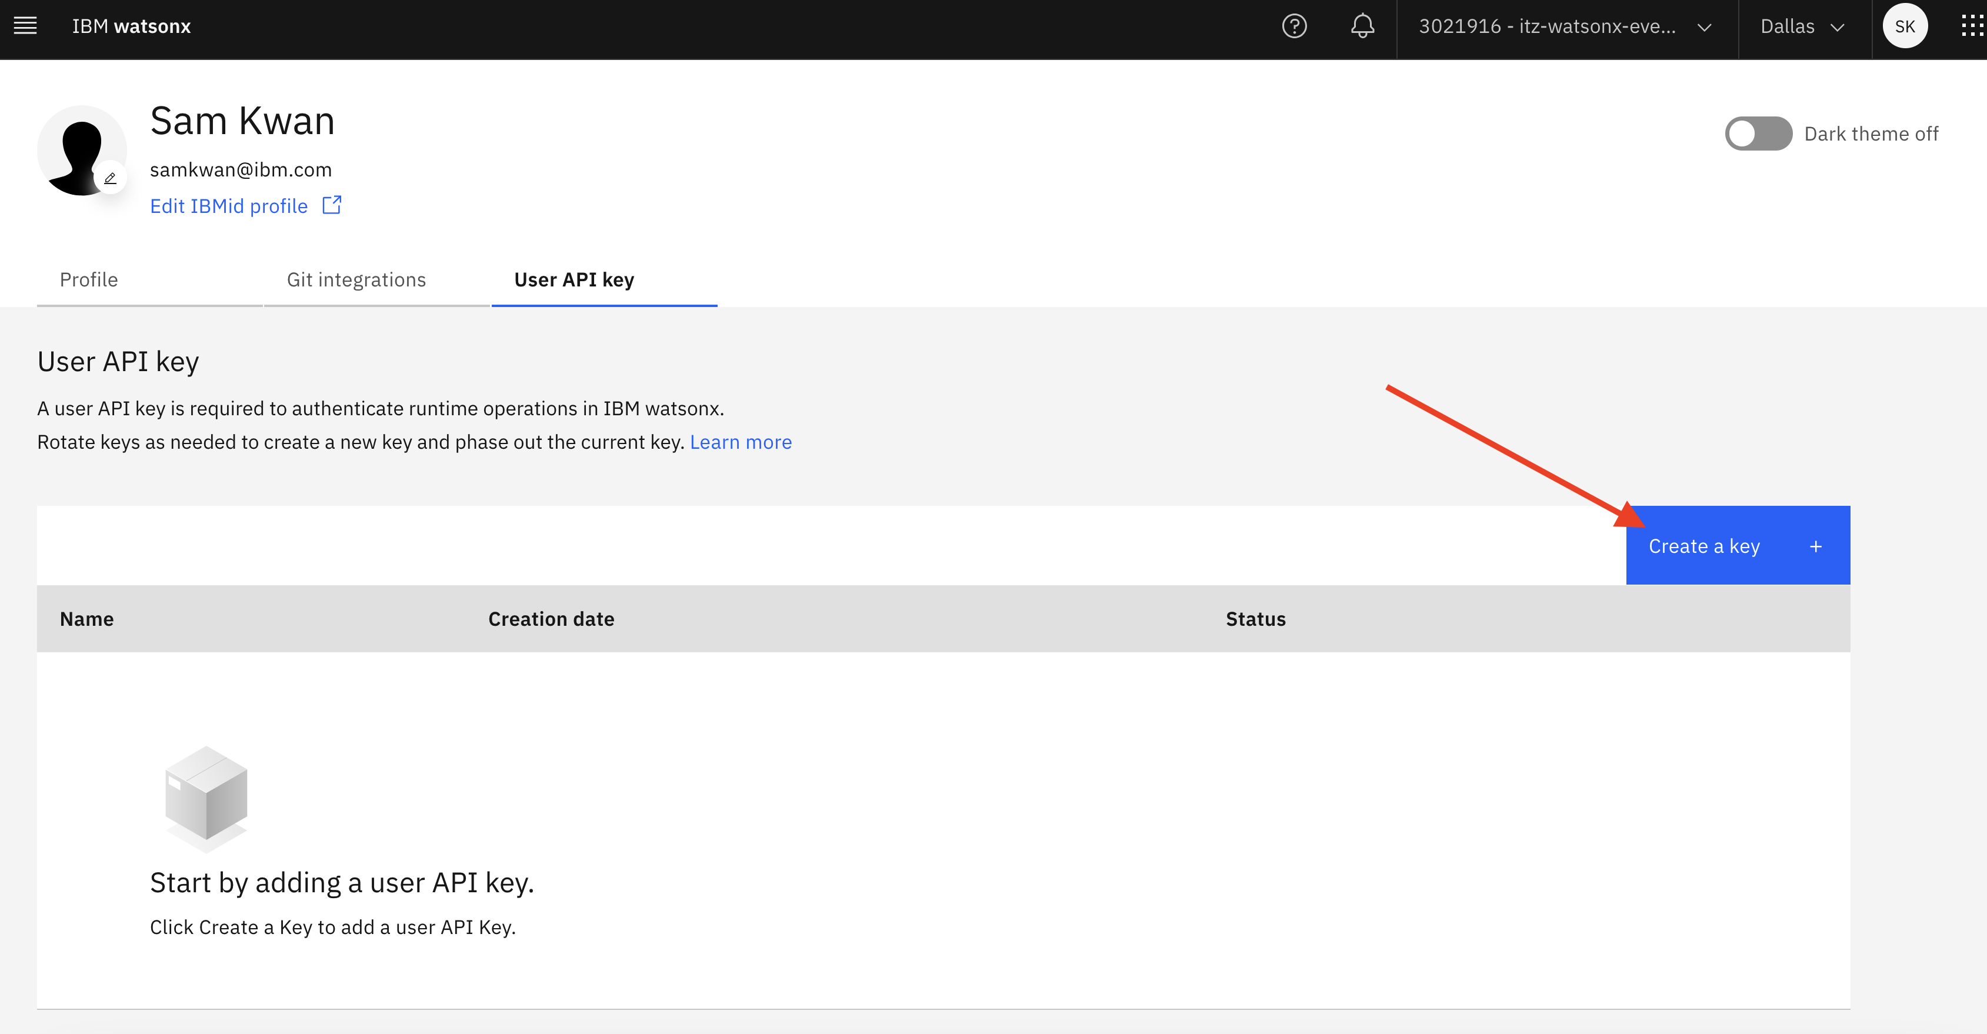

1. Click on the Create button to create a new key. The new key will be listed as shown below. If you already have a key listed, you are good to go and don't need to do anything.

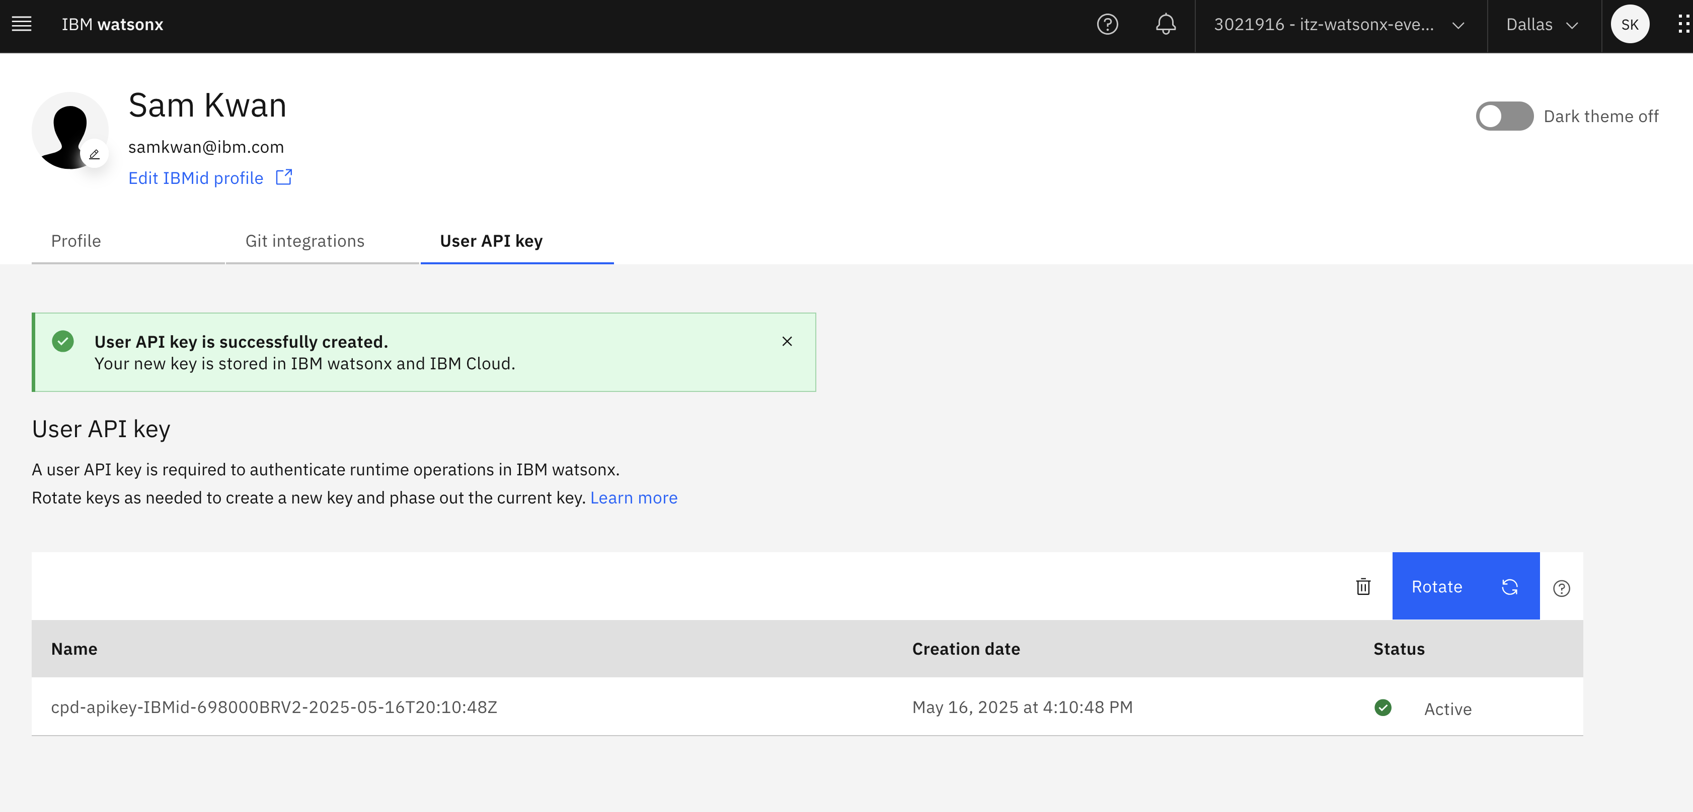

# Part 1: Setup Deployment Space for LangGraph Agent

To deploy the agent, you will need the following information to update in a config.toml file later:

* the API key for your watsonx.ai instance
* the Space GUID for the deployment space where the deployed agent will go
* the watsonx.ai URL: <https://us-south.ml.cloud.ibm.com>

1. For API key, click the hamburger menu at the top left corner, then choose A**ccess (IAM)**.

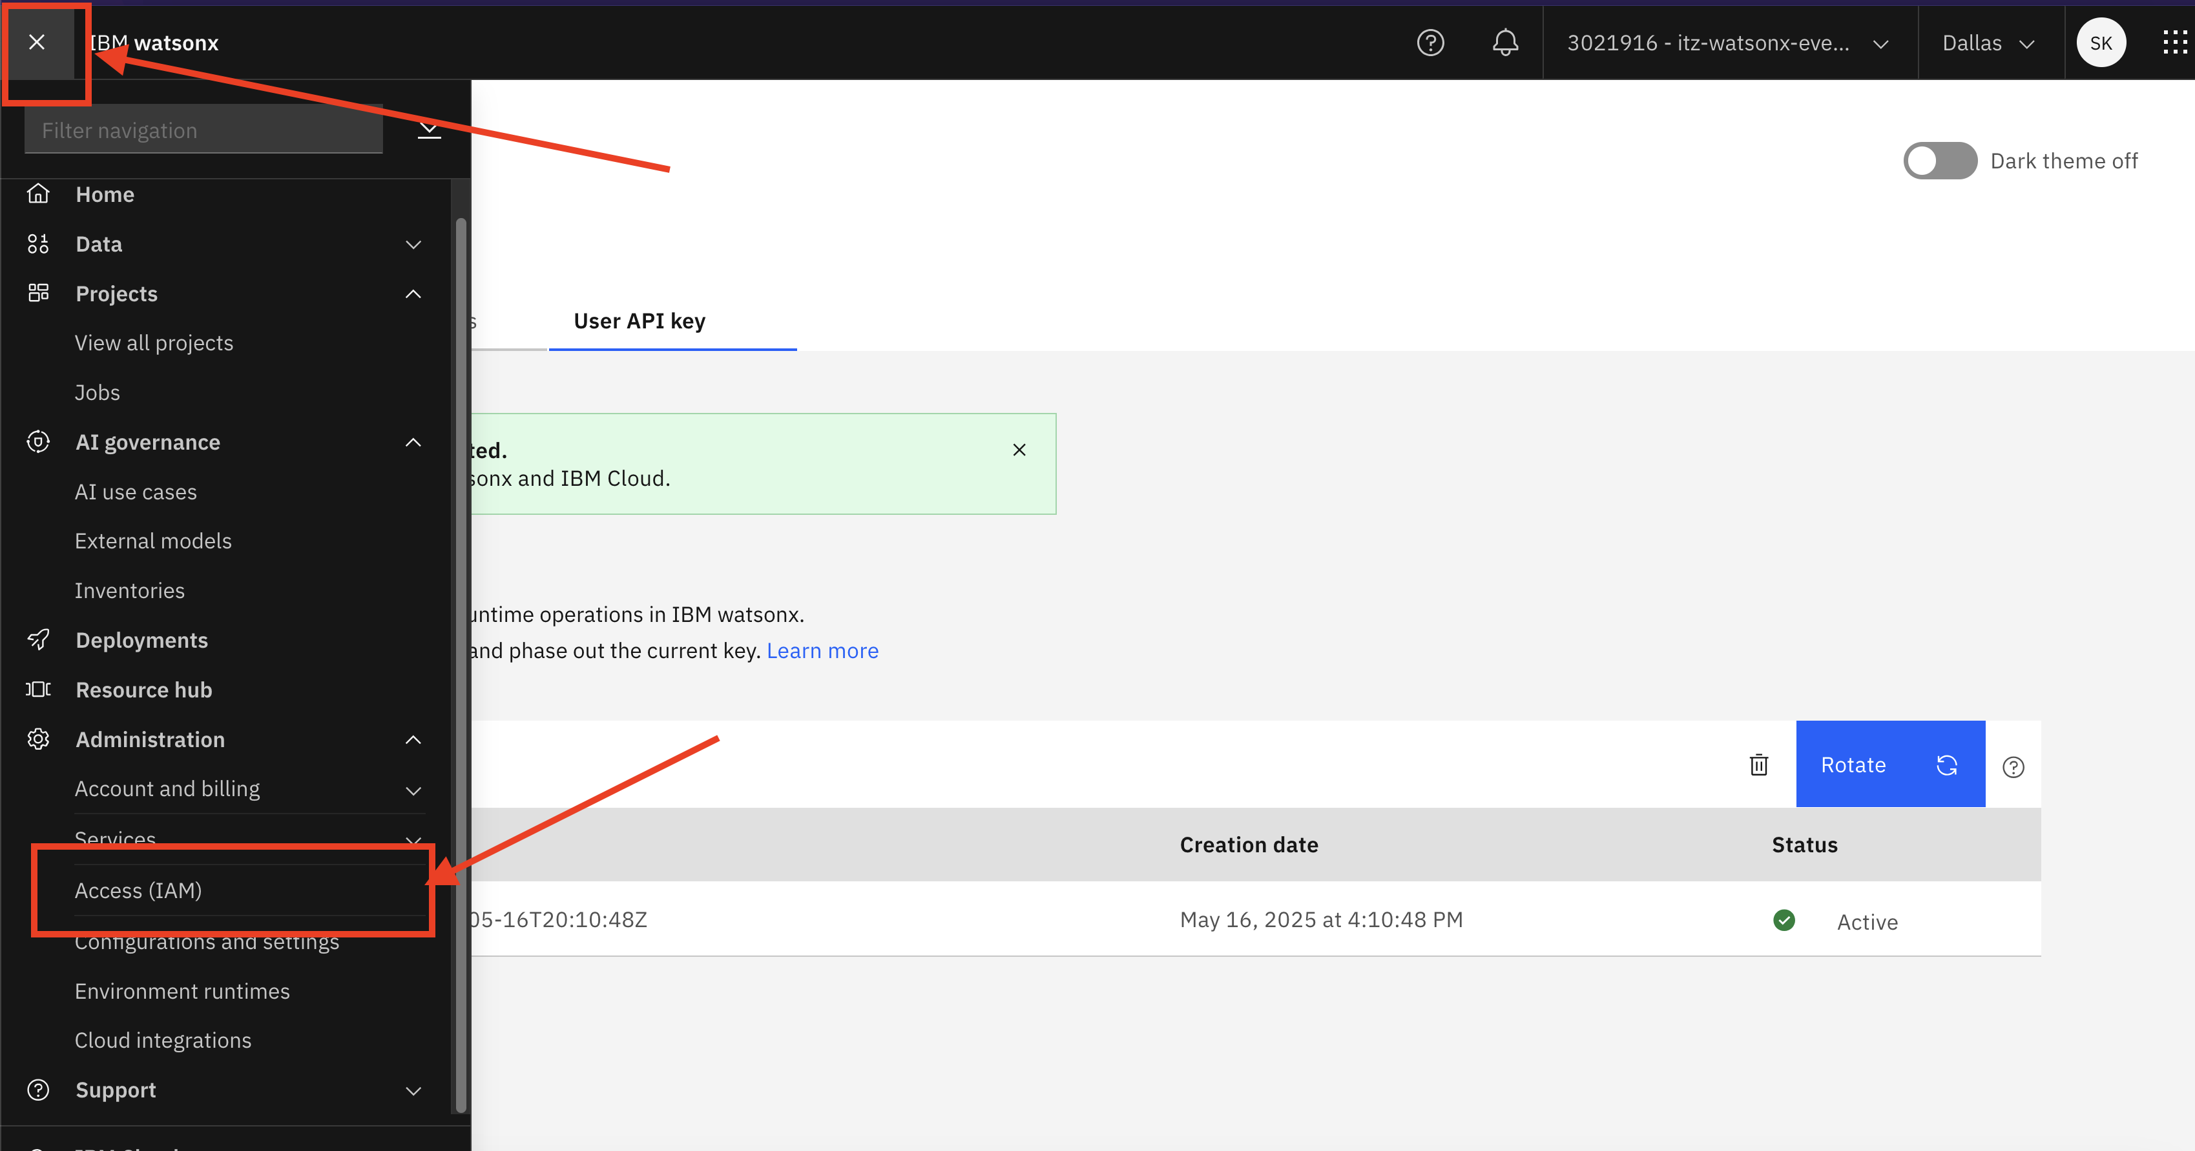

1. Click the **API Keys**.

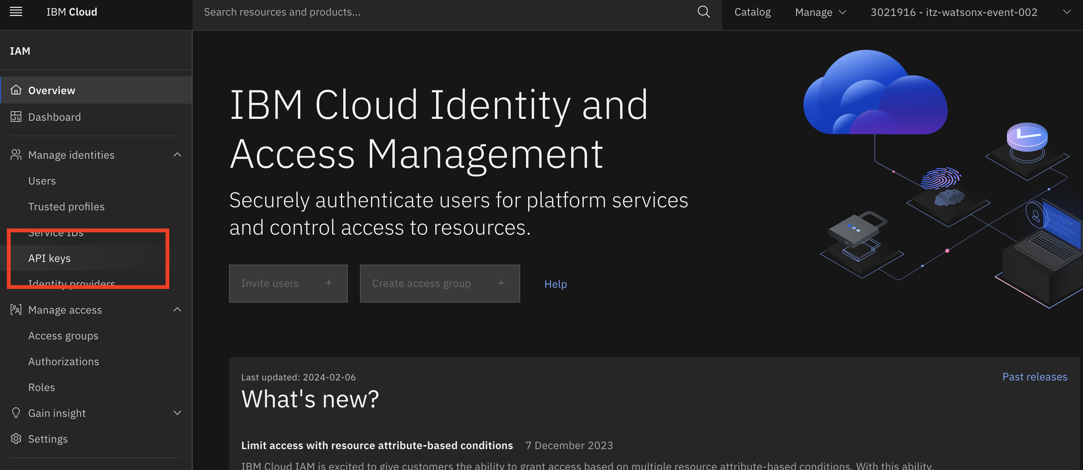

1. Click the blue **Create +** button, name your API key, then click **Create.**

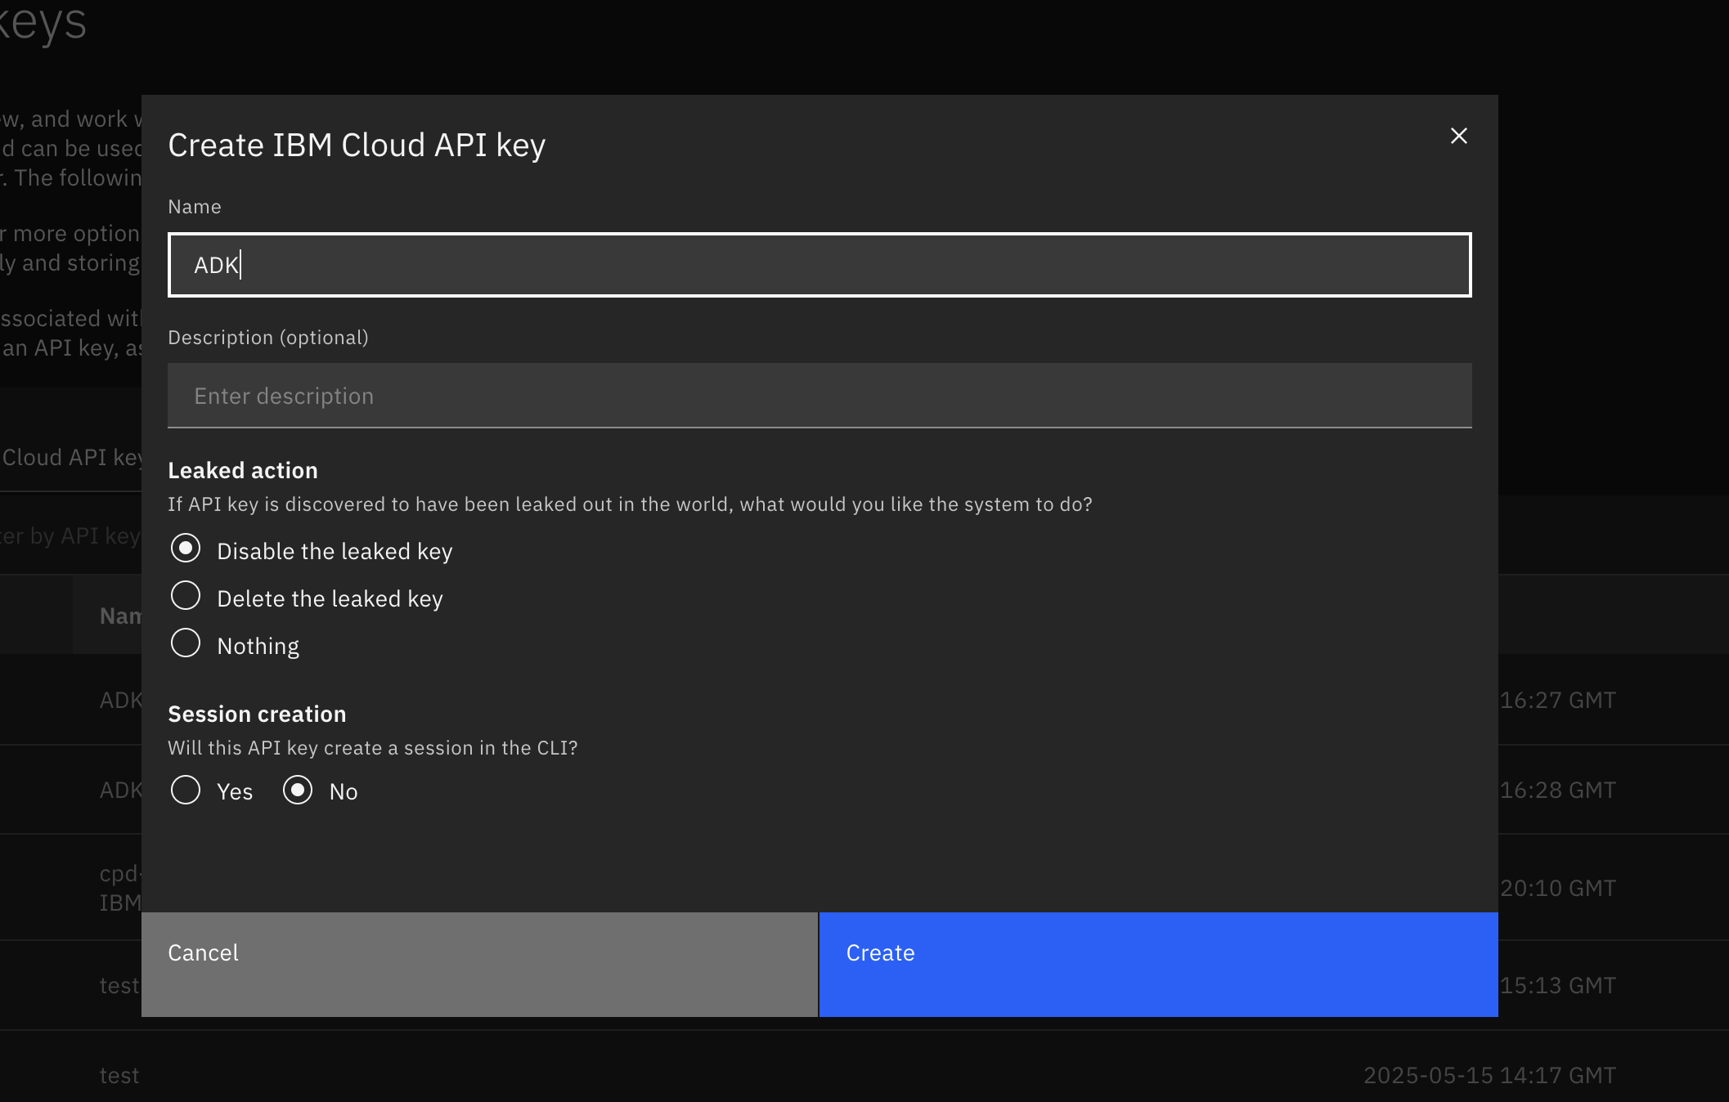

1. Copy and save the API key in a notepad or download the API key json file.

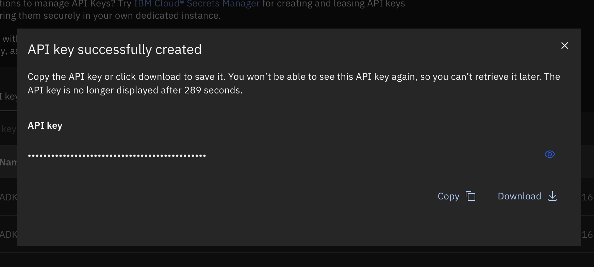

1. For the Space GUID, go back to the **watsonx.ai instance** like what you did in step 1 – 3 (or use this link <https://dataplatform.cloud.ibm.com> ). Then click the hamburger menu button and choose **Deployments -> View all deployment spaces**.

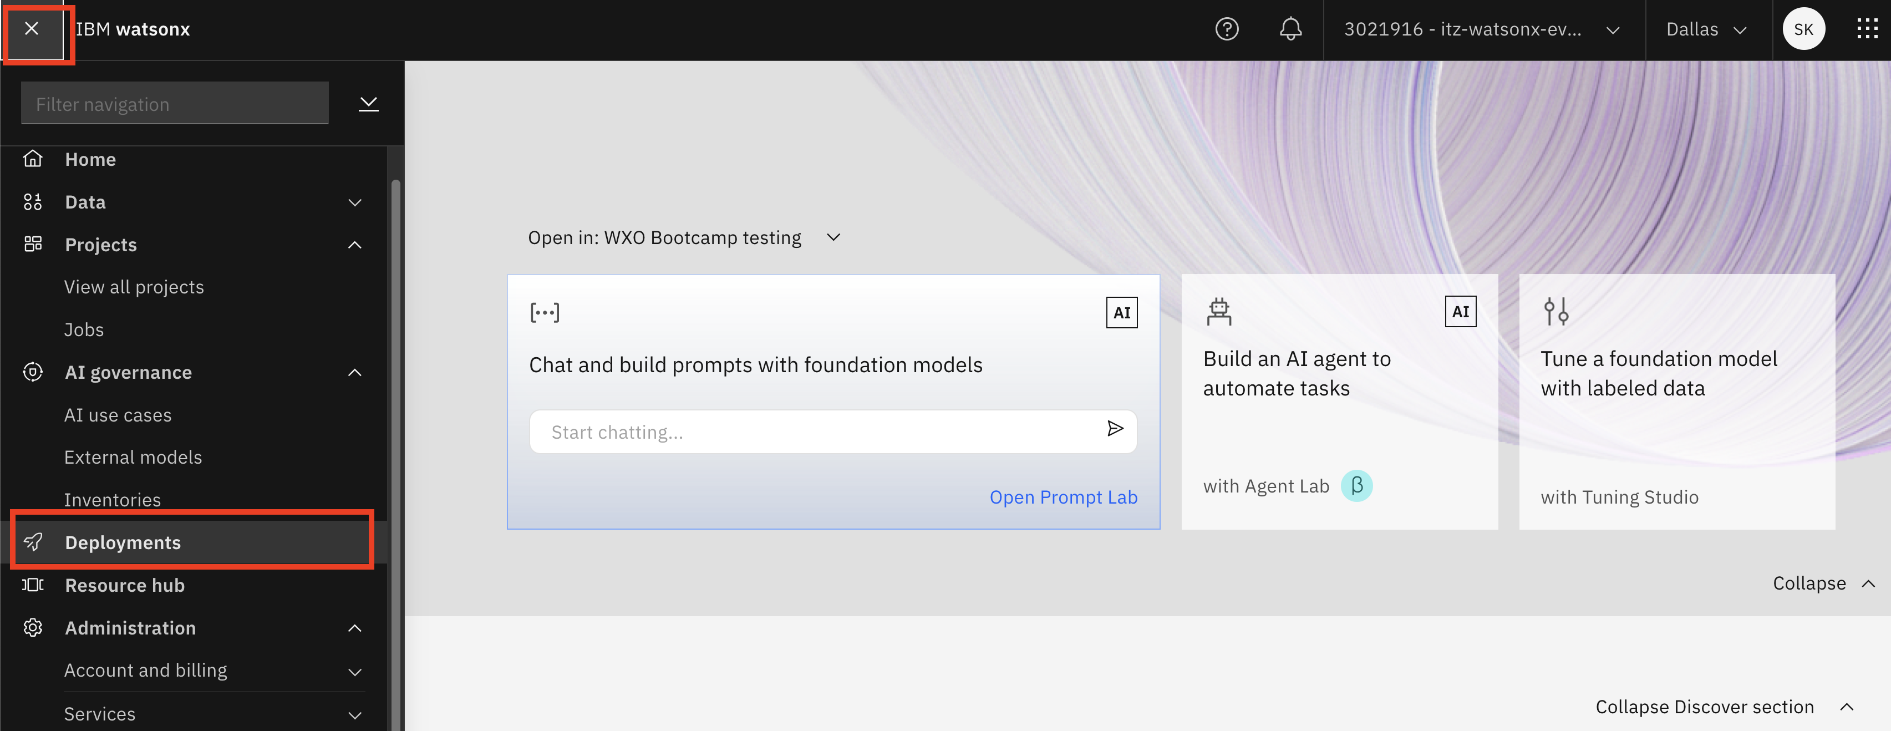

1. Click **New deployment space +** .

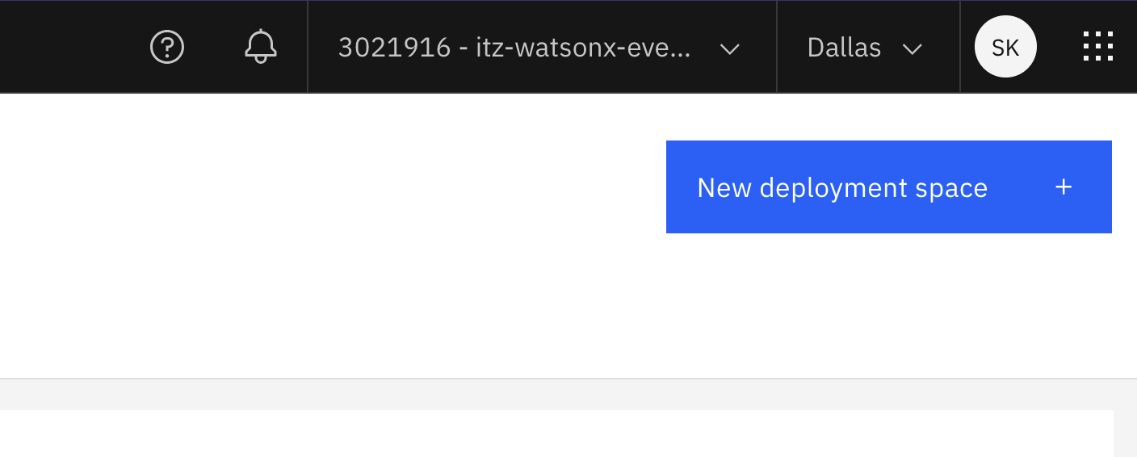

1. Give a name for the deployment space, in Watson Machine learning, select the only option (wml-itz-wxo.xxxx) , then click **Create.**

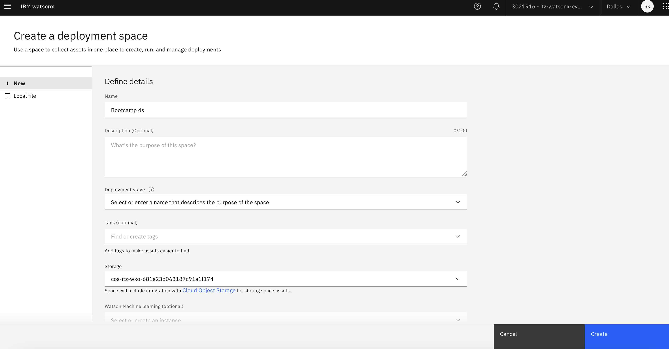

1. Once created, click **View new space**, go to the **Manage** tab, copy and save the Space GUID.

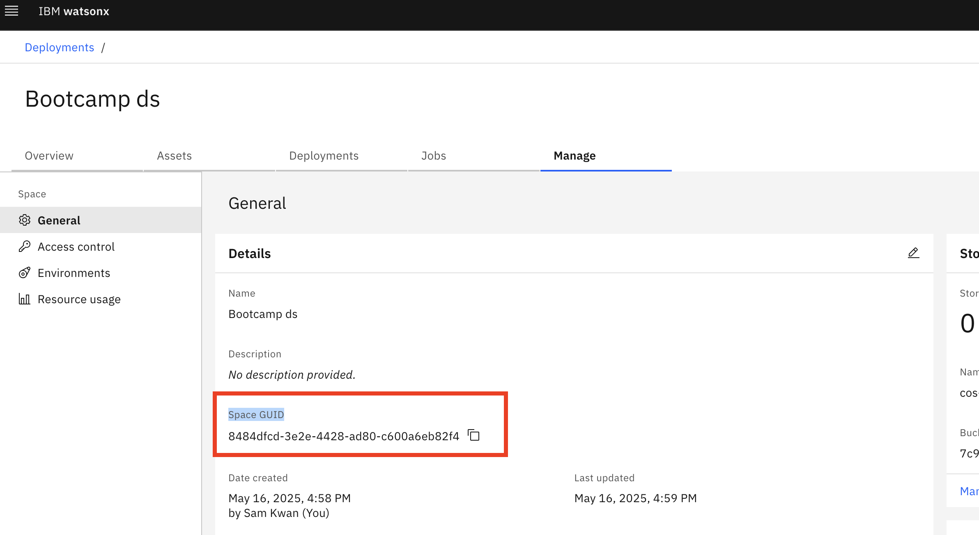

# Part 2: Prepare the agent

Now we are going to download the source code for the LangGraph agent and ready to deploy to watsonx.ai Runtime.

1. In the material zip file, find the langgraph-react-agent.zip file and unzip the file.
2. Open your VSCode, open the folder where you unzipped the langgraph-react-agent file, then use your terminal to run the command below:

|  |
| --- |
| cp config.toml.example config.toml |

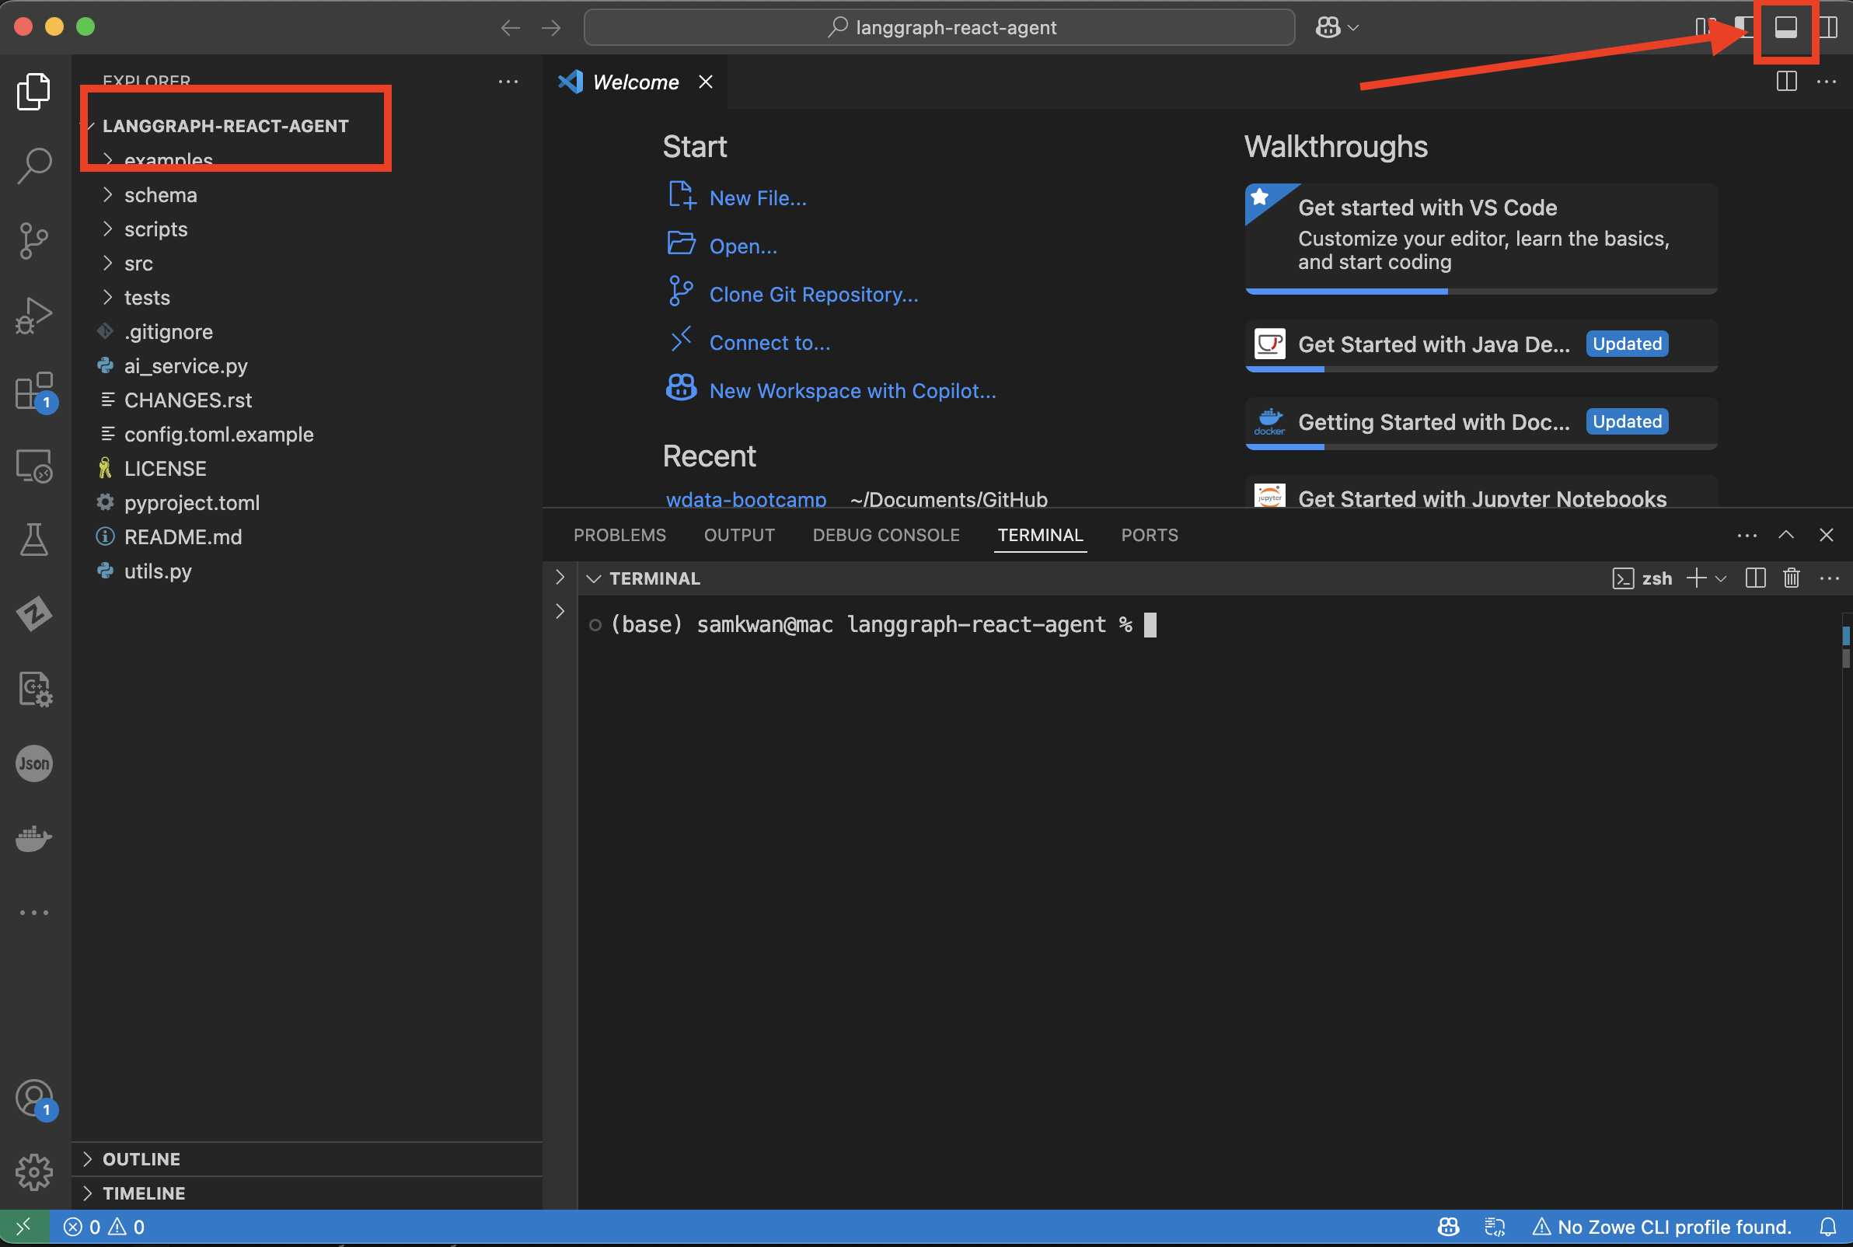

Copy and paste the command above and hit Enter.

1. Edit the config.toml file with an editor of your choice and add the API key, Space ID and URL you collected earlier in the file as indicated.

* In [deployment]:
  + watsonx_apikey (From Step 10)
  + watsonx_url (as <https://us-south.ml.cloud.ibm.com>)
  + space_id (From Step 14)
* In [deployment.online.parameters]:
  + url (as <https://us-south.ml.cloud.ibm.com>)
* In [deployment.software_specification], set overwrite = true

*Note that the URL appears in two places (as watsonx_url and url), and you have to update both.

A total of **five changes** should be made in the file.

**Remember to Save** the file when done.

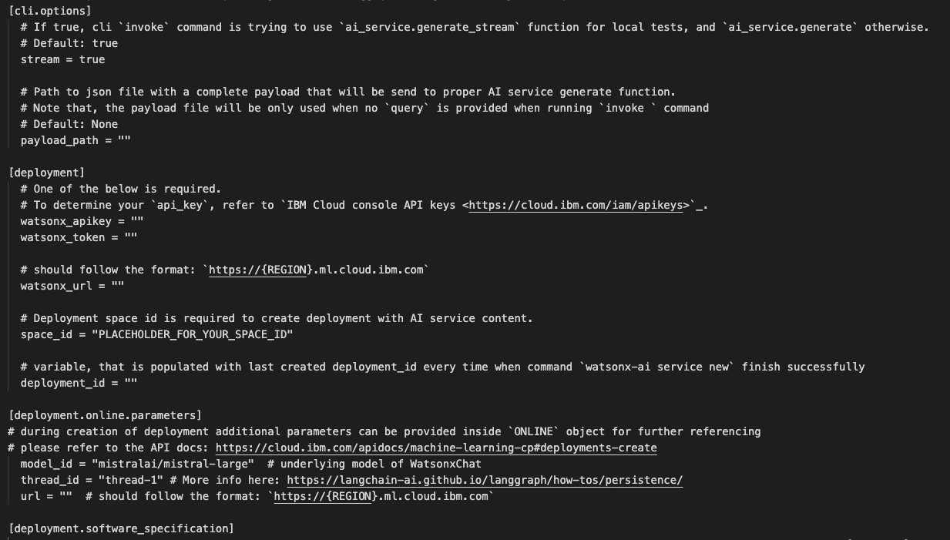

1. Optionally explore the agent and tool source code under

src/langgraph_react_agent_base.

* agent.py is the code for building the LangGraph agent.
* get_traffic_incident.py is the code base for the custom tool.

# Part 3: Deploy LangGraph Agent to watsonx.ai Runtime

We’ll now deploy the agent using the watsonx.ai CLI.

1. Now we need to create a Python environment and download the watsonx.ai CLI. In the same terminal, run the following commands on your laptop

|  |
| --- |
| python3.11 -m venv venv  source venv/bin/activate  pip install --upgrade pip  pip install ibm-watsonx-ai-cli  pip install poetry |

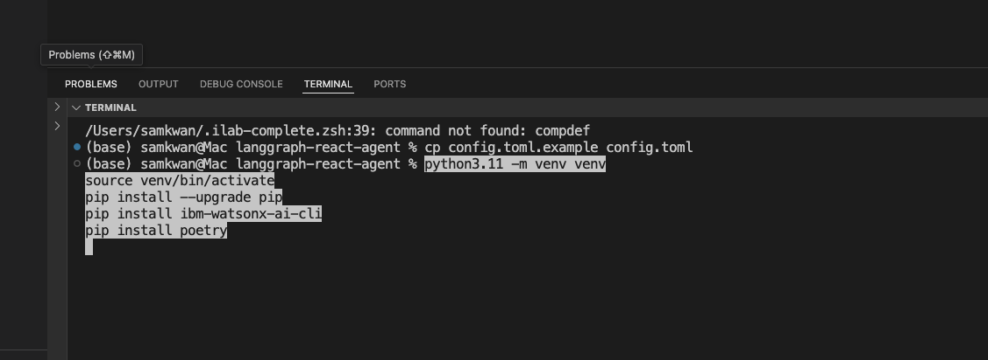

1. You are ready to deploy it in watsonx.ai. Run the following command to create the new service. It will take the agent code, package it up and deploy it into the space.

|  |
| --- |
| watsonx-ai service new |

On your screen, it should look like this:

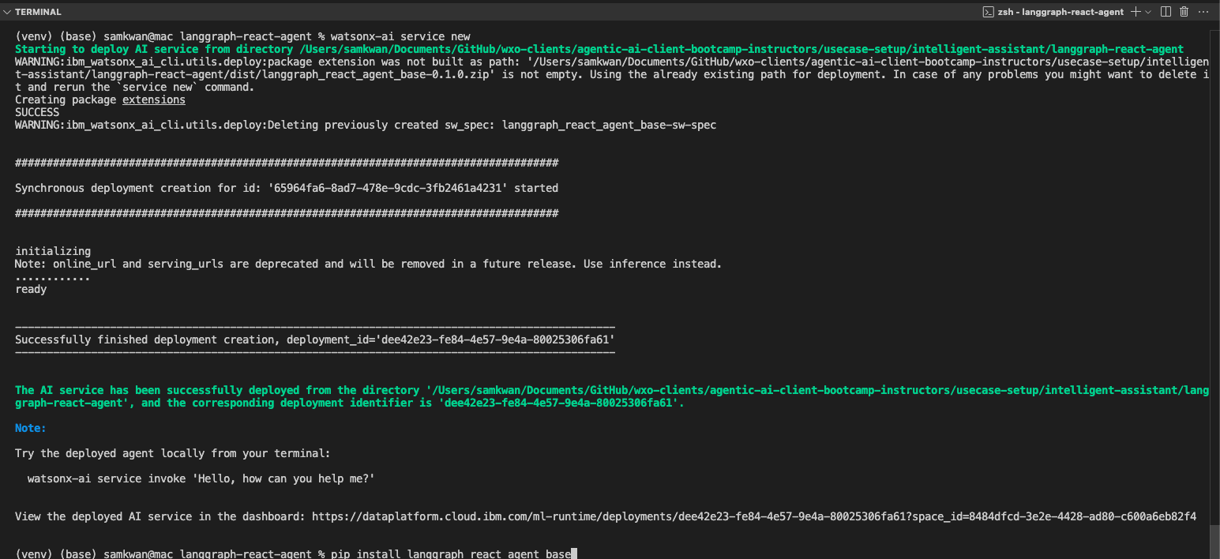

1. After deployment, note the "**View the deployed AI service in the dashboard**" message. Open the provided URL in your browser.
2. On the page, there is one important detail you need to capture, namely the **public streaming endpoint URL**. The picture above shows where you can find it and copy it to your clipboard. Save this URL.  
     
   **Make sure you are copying the bottom URL under Public endpoint!**

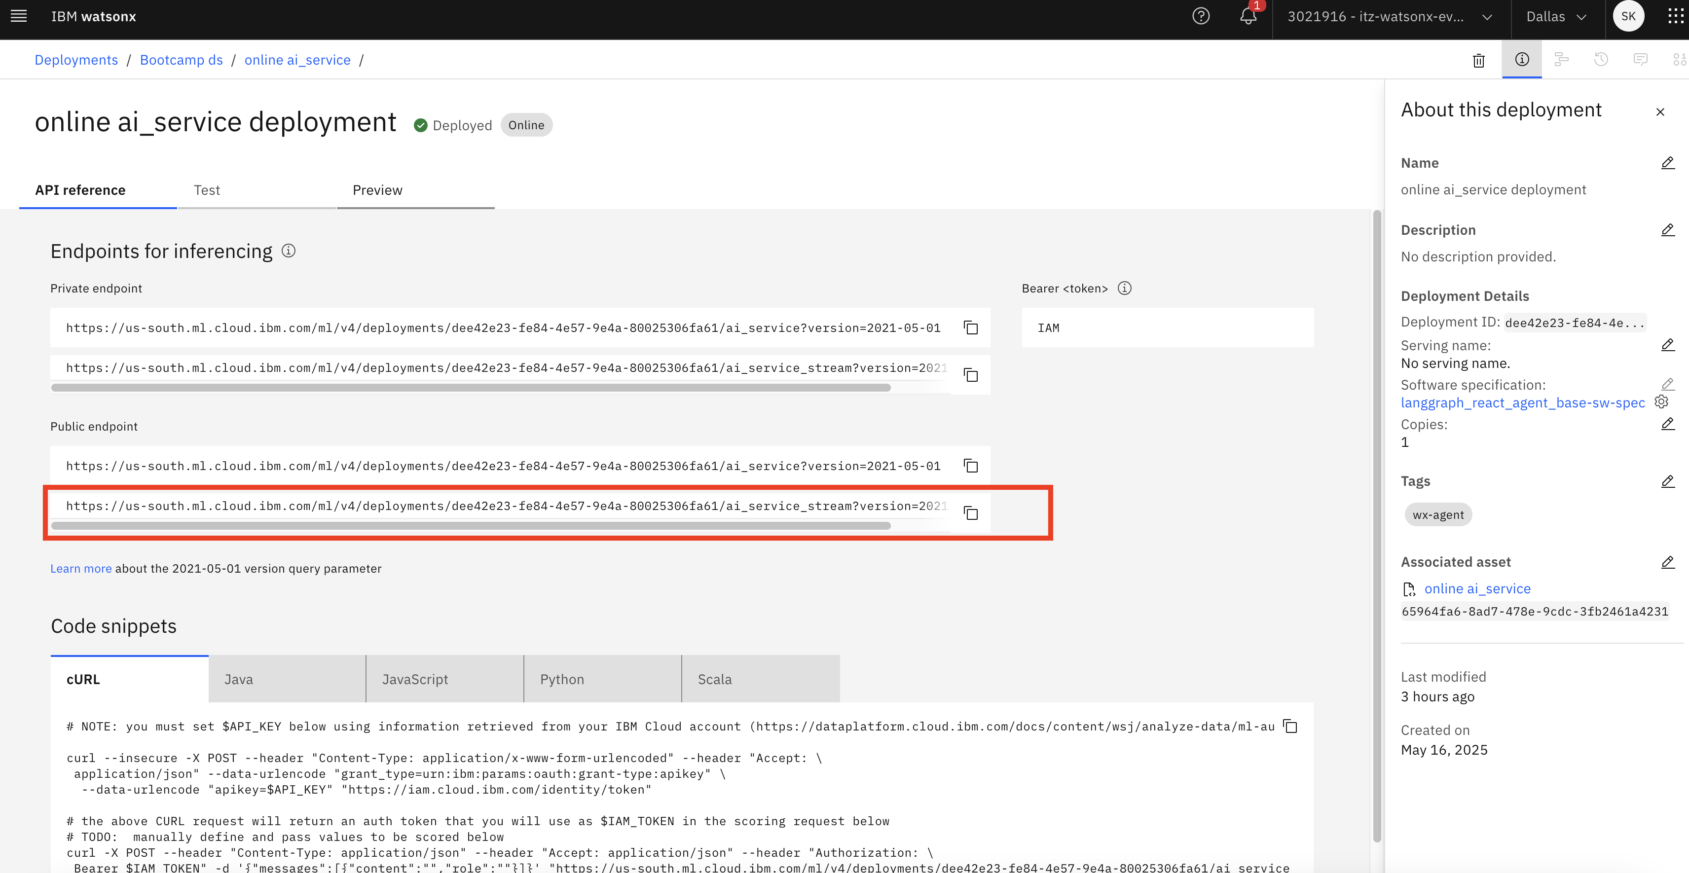

1. Now make sure the deployed service works as expected. Back on your command line terminal, first run the list subcommand again to see the deployment and then invoke the service:

|  |
| --- |
| watsonx-ai service list  watsonx-ai service invoke "What is the traffic situation in downtown Toronto?" |

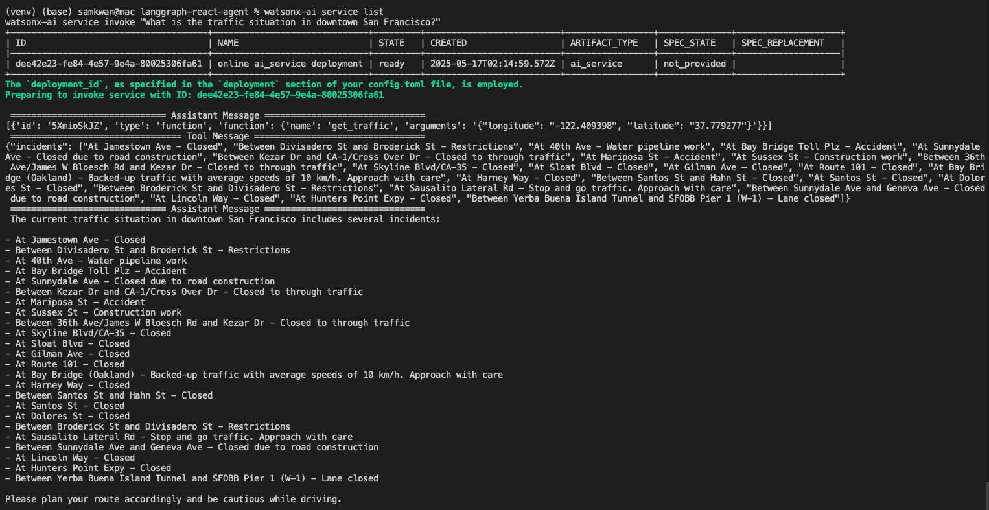

# Part 4: Connect the Agent to watsonx Orchestrate

Now we can integrate the LangGraph agent deployed on watsonx.ai to watsonx Orchestrate. The LangGraph agent is completely opensource and WXO can integrate agents deploy on different technology stack or even in another vendor as long as the agent follow the output schema.

1. Go back to [IBM Cloud](https://cloud.ibm.com/) Console, click the hamburger menu button (☰) on the top left corner. Then click **Resource list**. And click **watsonx Orchestrate** then click **Launch watsonx Orchestrate**.

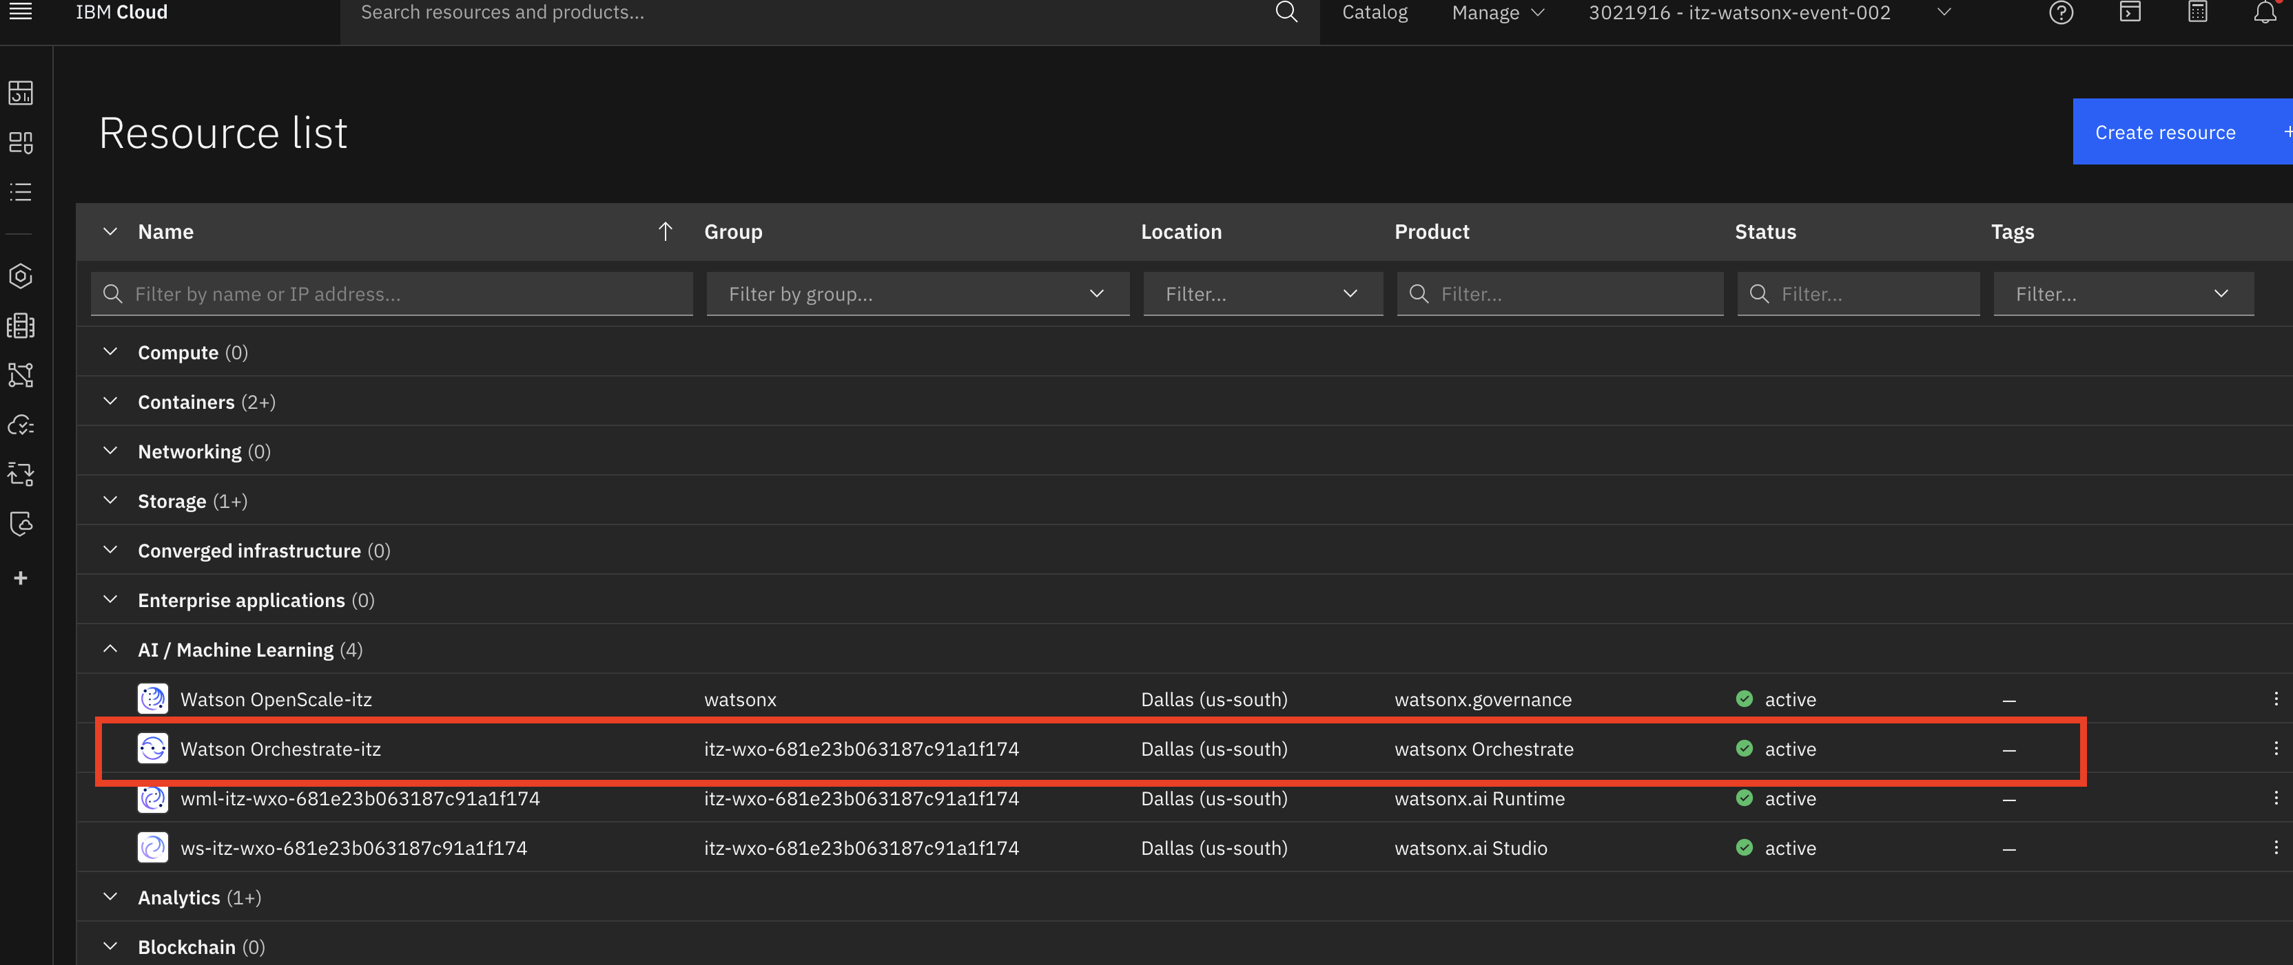

1. You will be navigated to watsonx Orchestrate main page. Before we integrate the LangGraph agent, you can try to interact with watsonx Orchestrate.

Since the system has no agents available to route any request to, it might not be able to answer some of the questions. But you can still interact with the Large Language Model (LLM) that works behind the scenes, and ask general questions, like “How are you today?" or "How is the traffic in Downtown Toronto?".

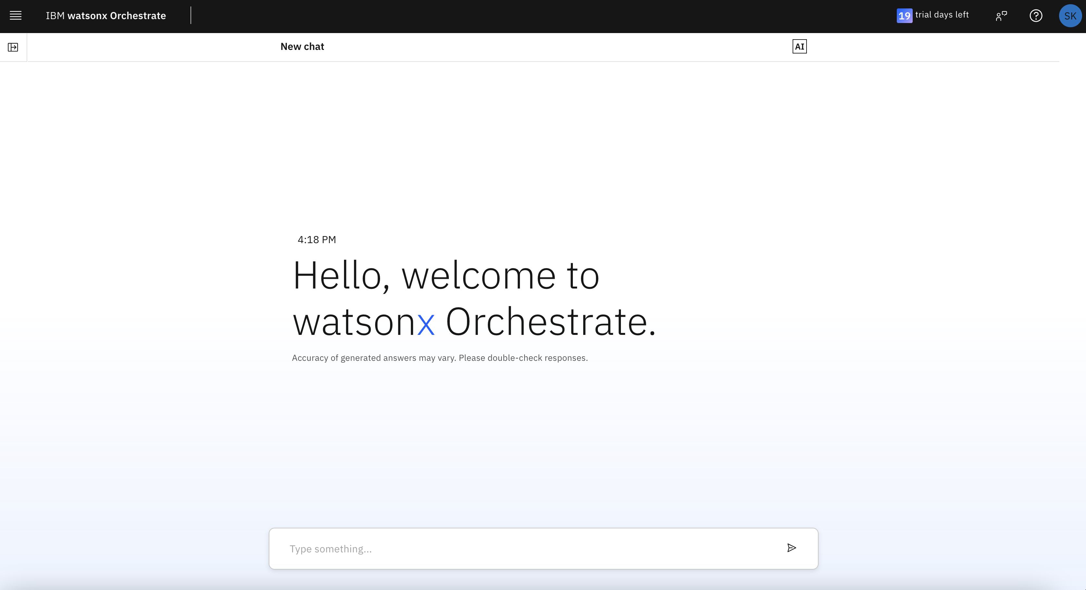

1. Click the hamburger menu button on the top left corner, click **Build** and **Agent Builder.**

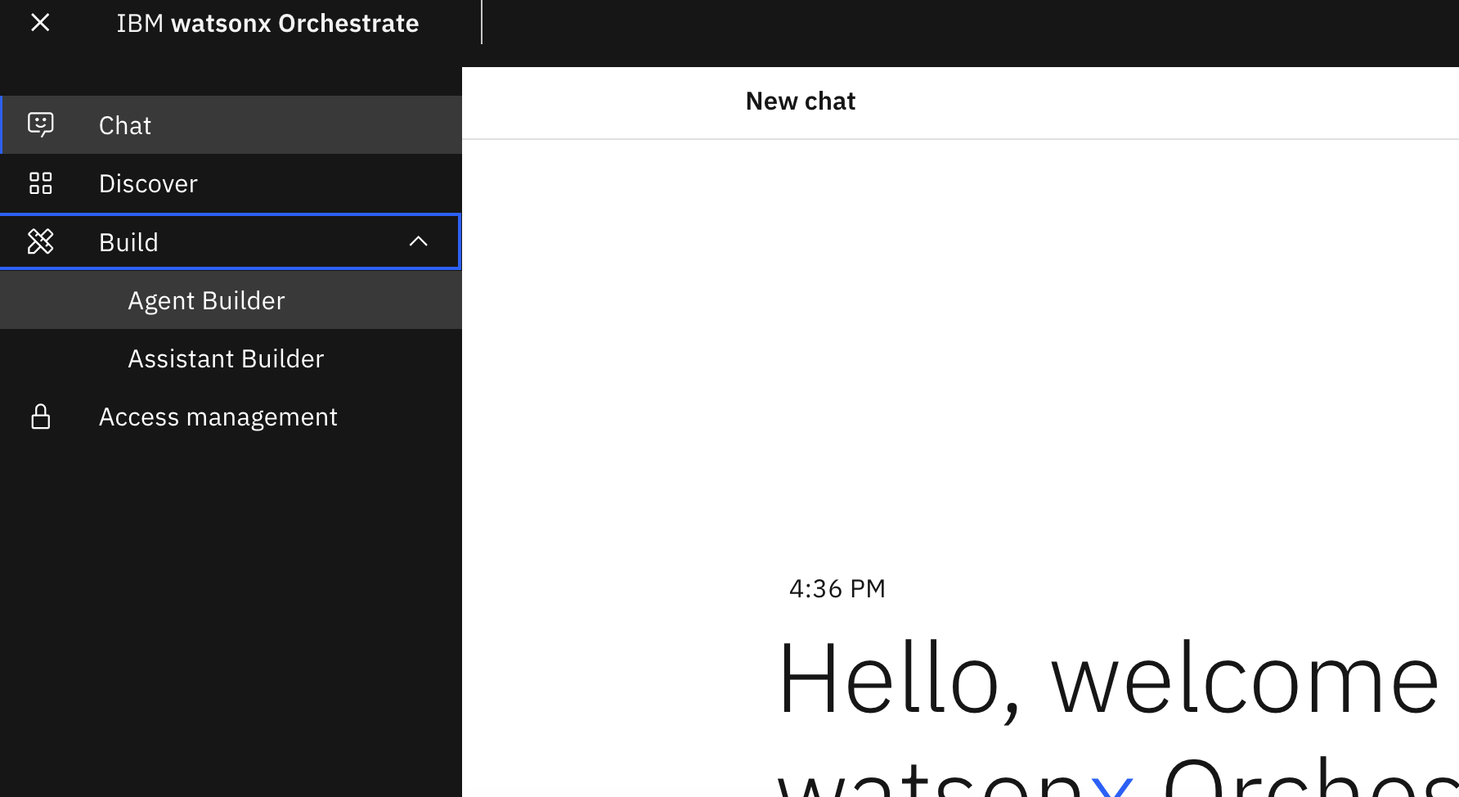

1. Click **Create agent +** , keep it as **Create from scratch** give it the name **Traffic Agent**, copy and paste the below to description then click **Create**

|  |
| --- |
| The Traffic Agent is responsible for providing real-time traffic information and answering inquiries related to traffic conditions in specific locations |

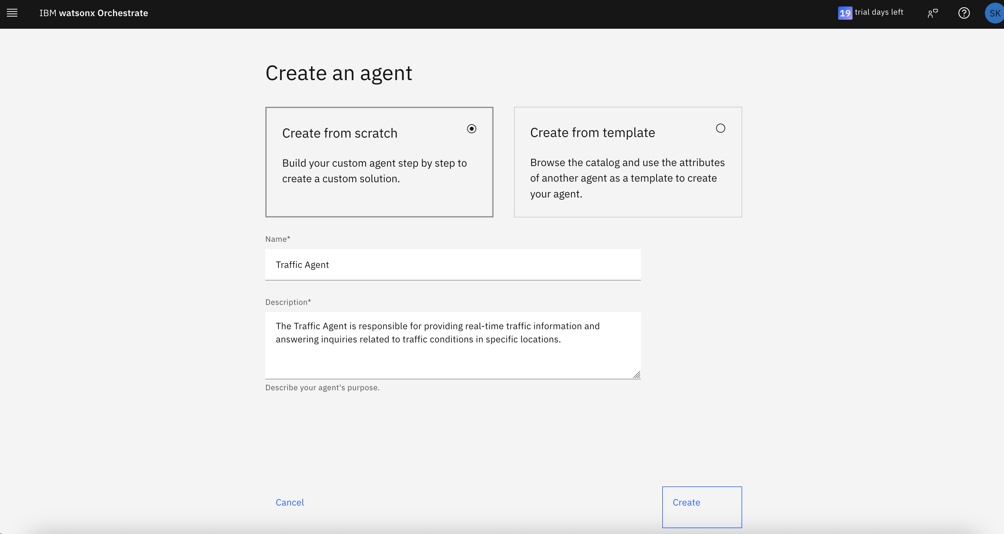

1. Now scroll down until you see the **Agents** section under Toolset, then click **Add agent**

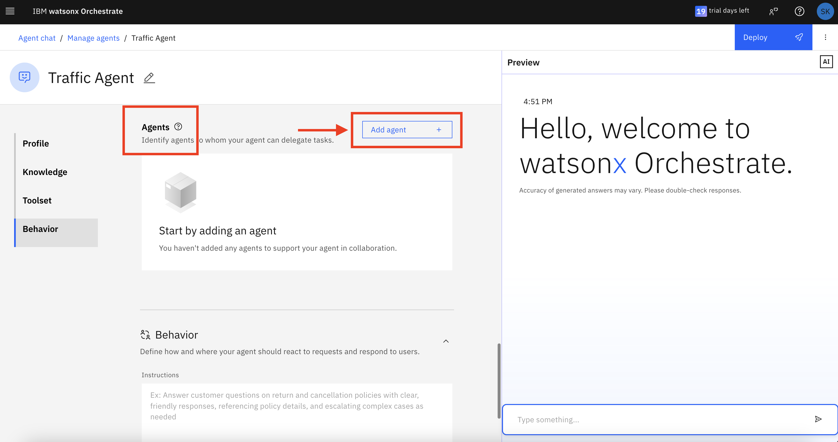

1. Choose **Import** option, this will allow us to import the agent from watsonx.ai or external agent

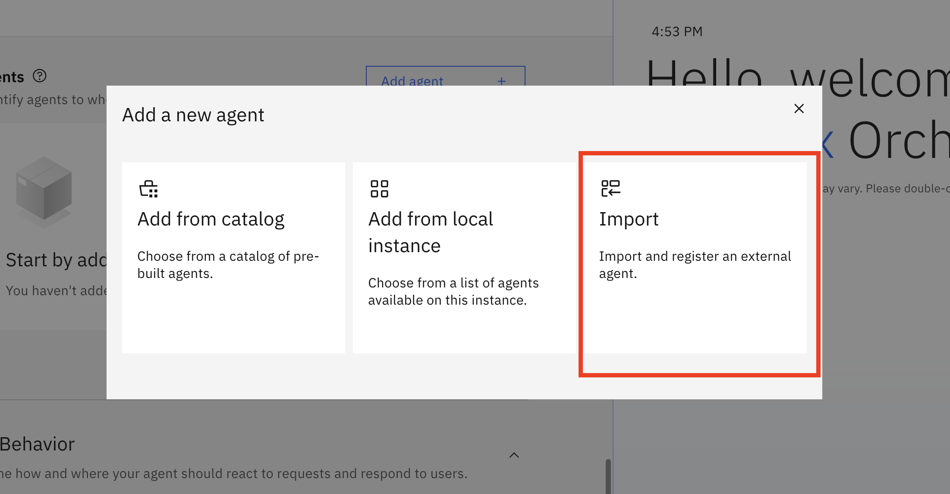

1. Select the External agent option and click on Next.

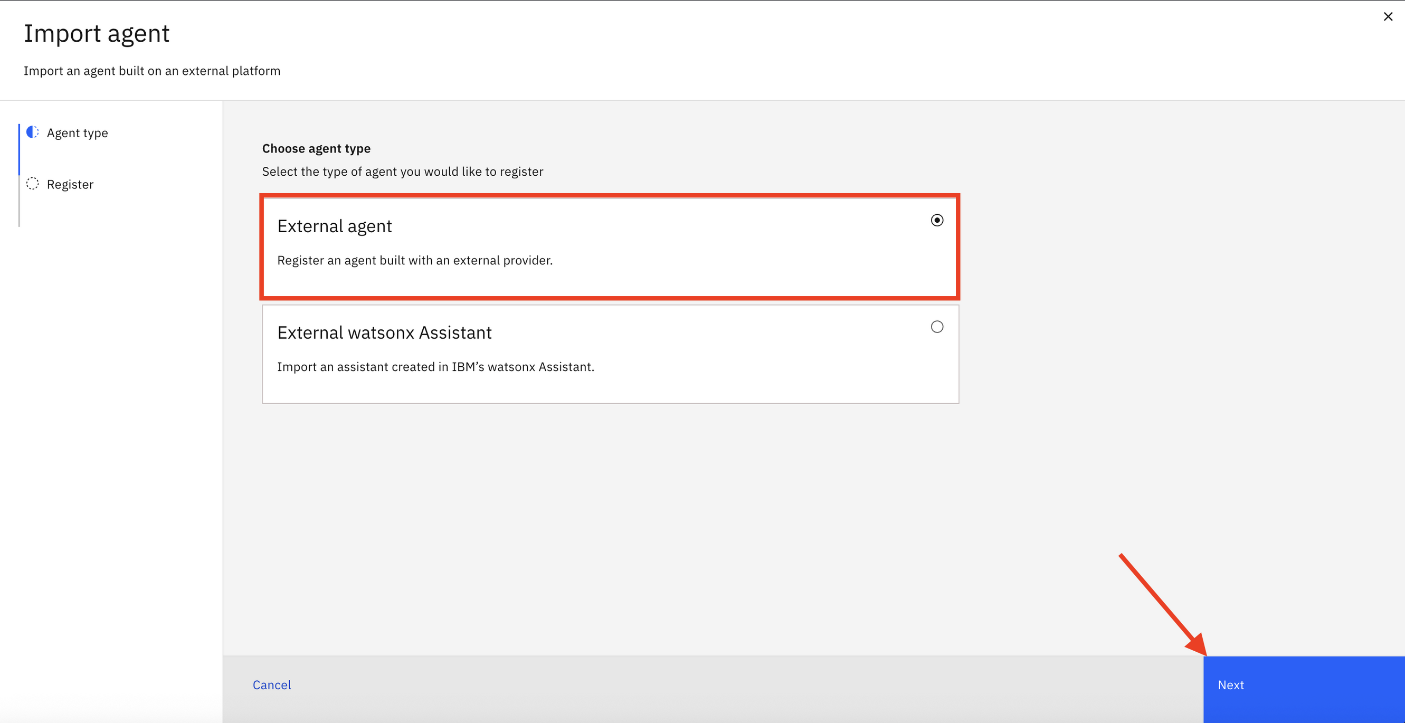

1. On the following screen, enter details about the imported agent:

* Agent details
  + Provider: watsonx.ai
  + Authentication type: leave as API key
  + API key: enter the key you collected at **STEP 10**
  + Service instance URL: enter the URL you collected at **STEP 22**
* Define new agent
  + Display name: **TrafficAgent** (the name cannot contain a space)
  + Description of agent capabilities: **The TrafficAgent agent provides information about traffic in any given location.**

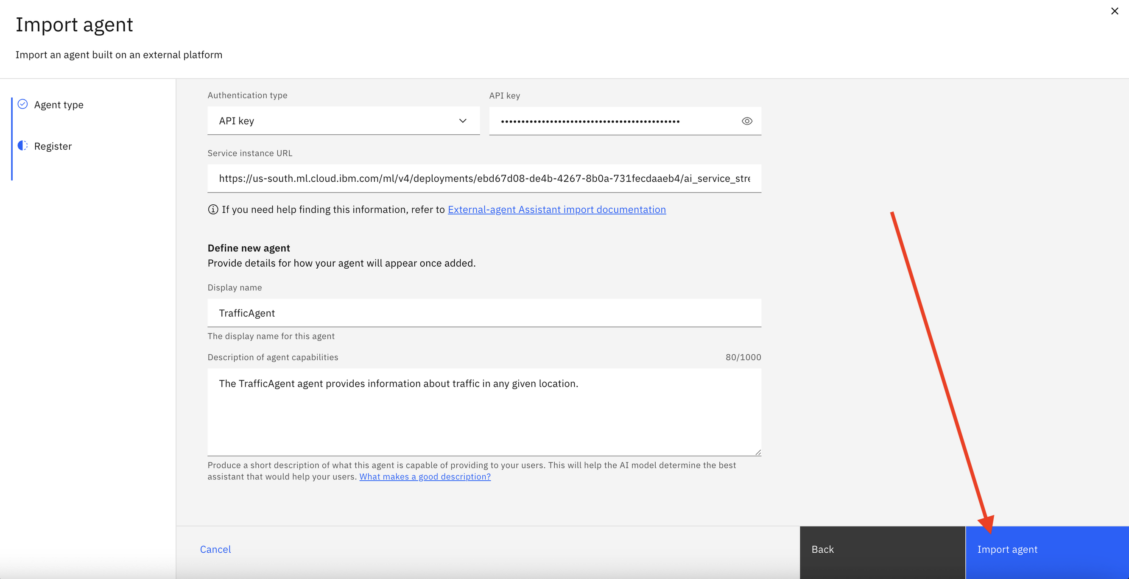

1. Then you should see the new connected agent appear in the **Agents** session.

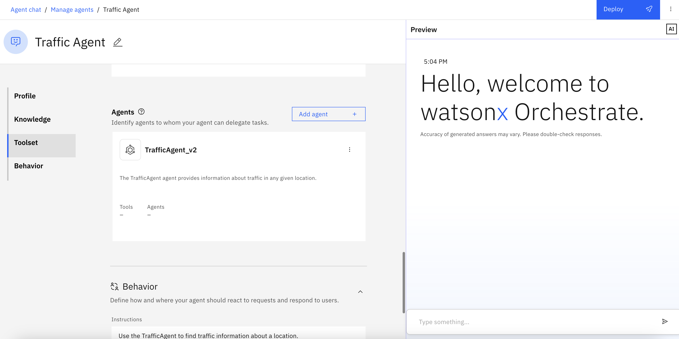

1. Scroll to the bottom and you will see a **Behavior** section.   
     
   Please try to draft the instruction by yourself so that the Traffic Agent can route the query to the external agent that you just imported! Such that it can answers questions like “Please tell me about traffic around Downtown Toronto”.  
     
   No worries! You can find our model answer at the end of this document — but please give it a try yourself before looking.

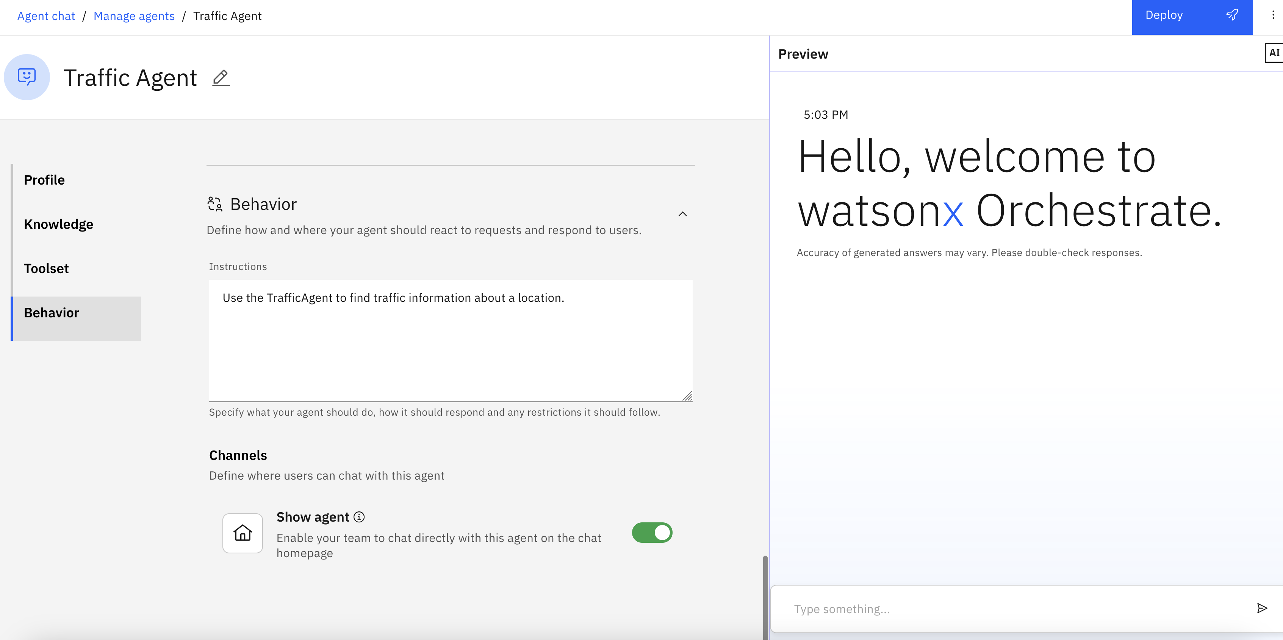

1. Let's test it before we publish the agent. Let's trigger the TrafficAgent agent by asking about traffic in a given location, say, Downtown Toronto. Enter the following into the **Preview** text input:   
     
   "Please tell me about traffic around Downtown Toronto." (You can obviously pick any other location too.)

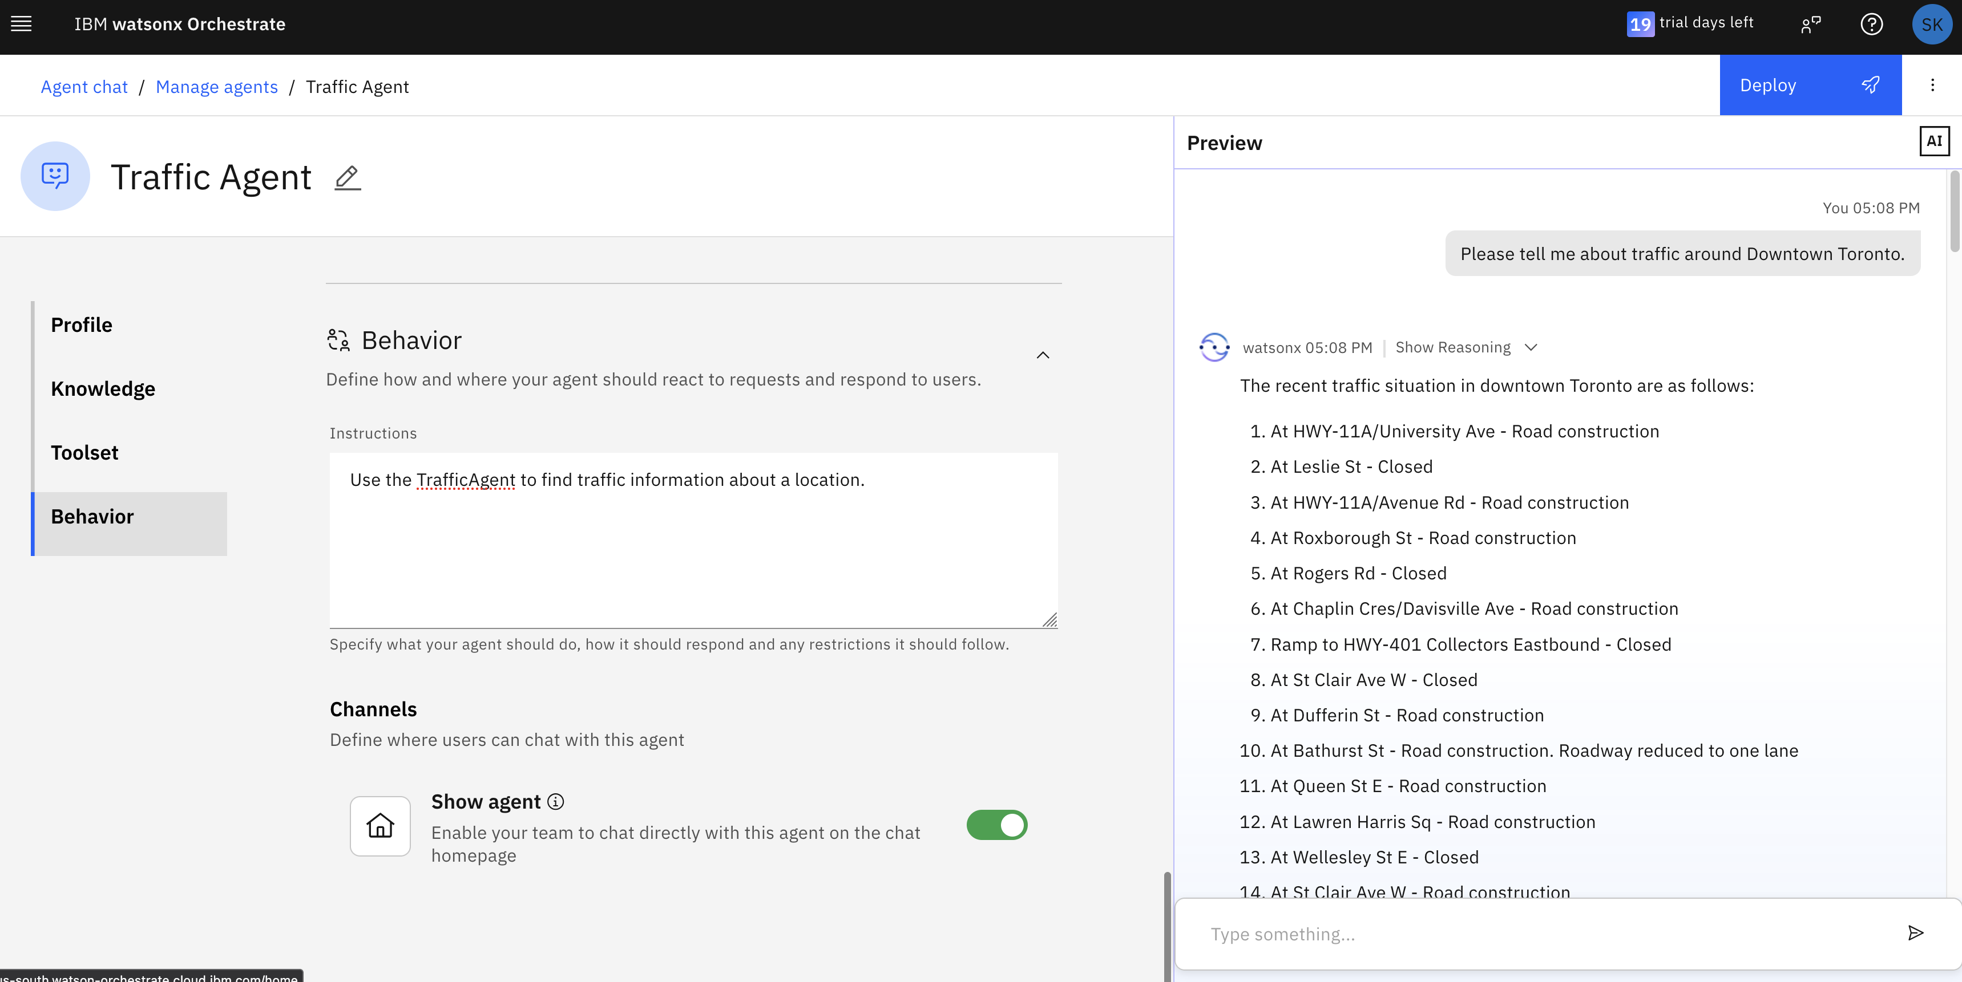

1. Note that the agent was "reasoning", in other words, determining how to answer this request.   
     
   Although there is only one collaborator agent in the Traffic Agent, it decided that routing the request to the TrafficAgent was the best option.   
     
   You can expand the Show reasoning section in the Preview and see which steps the agent took. It should list one step, which you can expand as well.

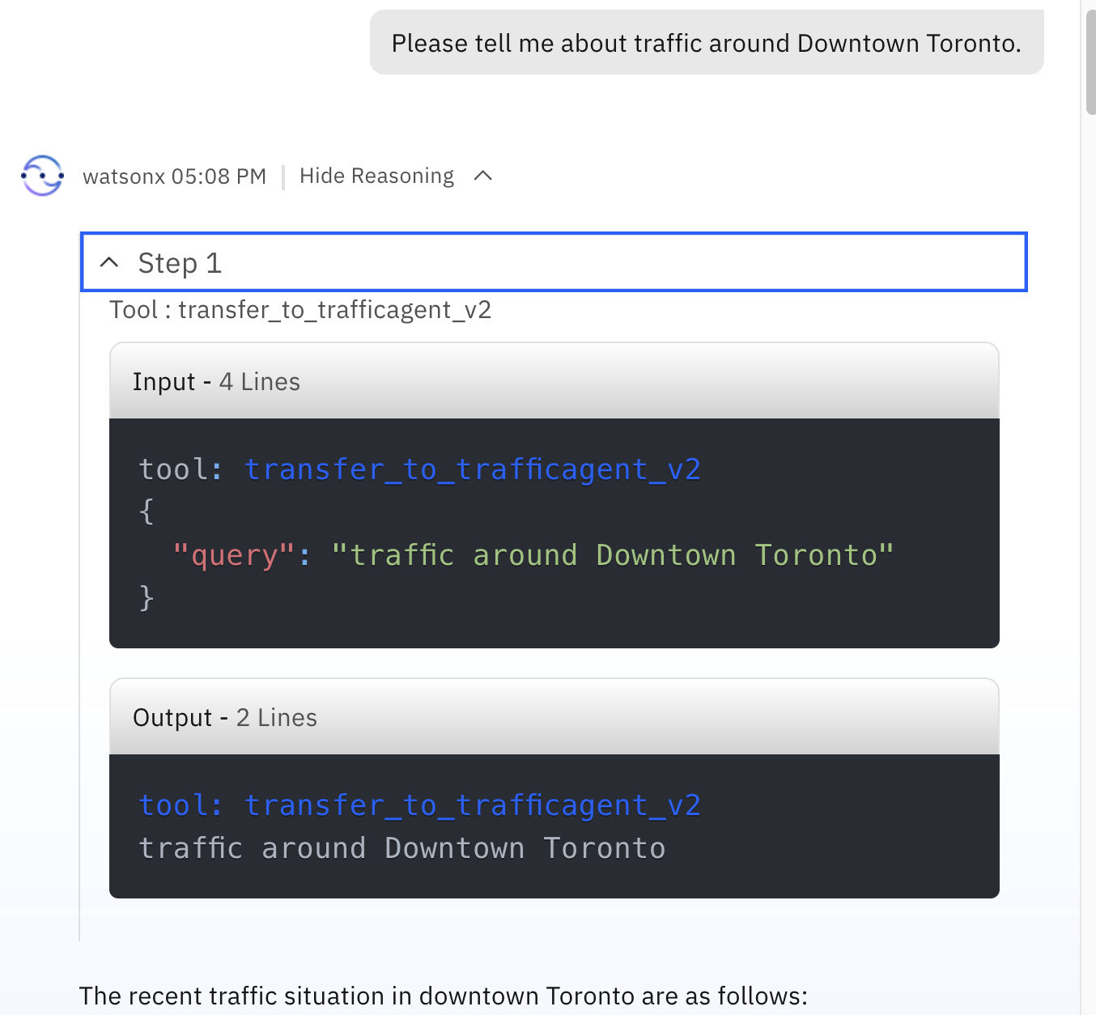

1. Once you are satisfied with the answer, deploy this agent using the Deploy button as with the other agents before.

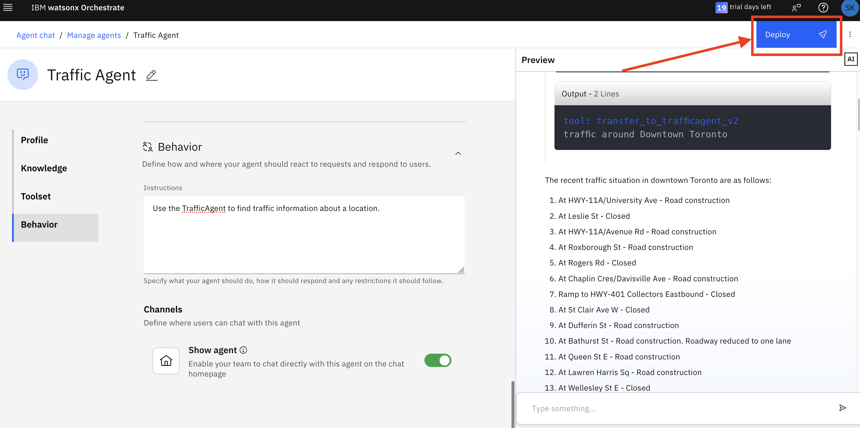

1. We can now go back to the home screen to see it there. Simply click on **watsonx Orchestrate** at the very top of the window.

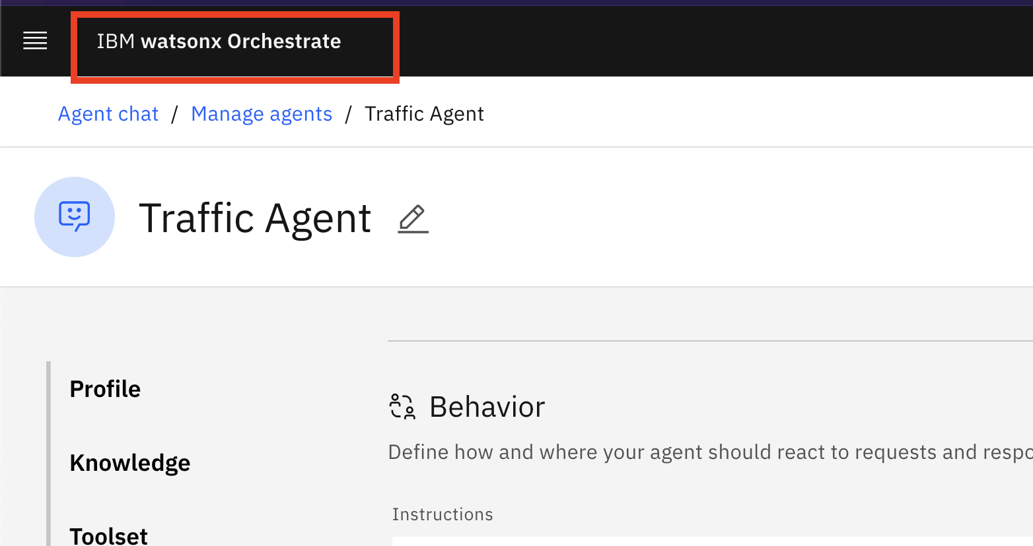

1. Make sure you select the **Traffic Agent** under the Agents list on the left. Now you can enter your questions and requests in the main chat window.

You can ask for any other location too!

“How is the traffic around Downtown Toronto?”  
“What is the traffic situation in downtown San Francisco?”

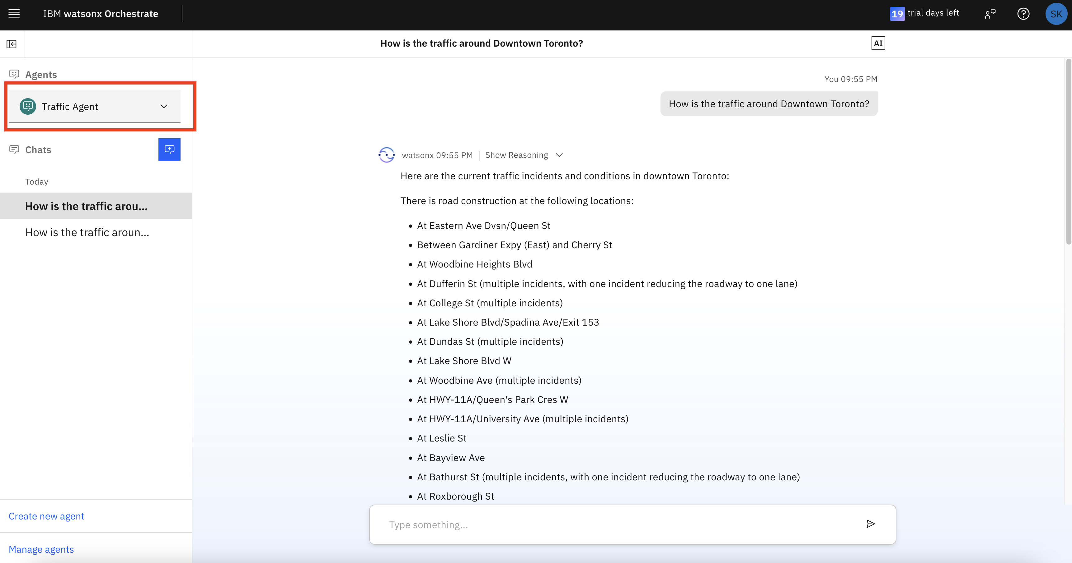

🎉 Congratulations!

You’ve successfully built an Agentic AI system by integrating a LangGraph agent with watsonx Orchestrate.

*The model answer for the Behavior of Traffic agent:

|  |
| --- |
| You are a agent responsible for providing real-time traffic information and answering inquiries related to traffic conditions in specific locations.  - Use the TrafficAgent to find traffic information about a location.  DO NOT show anything that is not related to the traffic report. Stop generating output after the list of traffic situation. |